BÀI TẬP 1
TỔNG HỢP KỸ THUẬT VIẾT MÃ NGUỒN VỚI CÁC CẤU TRÚC LẬP TRÌNH, LÀM VIỆC VỚI CÁC BIẾN, XÂY DỰNG CHƯƠNG TRÌNH/HÀM/THỦ TỤC
MINH HỌA TRÊN PYTHON VÀ JAVA
TRƯỜNG ĐẠI HỌC BÁCH KHOA HÀ NỘI
VIỆN CÔNG NGHỆ THÔNG TIN VÀ TRUYỀN THÔNG

BÀI TẬP NHÓM MÔN HỌC

IT3040 – KỸ THUẬT LẬP TRÌNH 2018-2019

HÀ NỘI 2019

Hà Nội, 2011

Hà Nội, 06/2009

Giảng viên hướng dẫn : PGS. TS. Huỳnh Quyết Thắng
Nhóm sinh viên : 1.
2.
3.
4.
5.
Lớp : KSTN_CNTT_K62
ĐỀ BÀI
Sử dụng các tài liệu sau:
- Bài giảng Introduction to Computer Science and Programming in Python
https://ocw.mit.edu/courses/electrical-engineering-and-computer-science/6-0001-introduction-to-computer-science-and-programming-in-python-fall-2016/index.htm
để học về ngôn ngữ Python và minh hoạ các kỹ thuật lập trình.

- Sử dụng tài liệu Steve McConnell. Code Complete, Second Edition; Publisher: Microsoft Press; Pub Date: June 09, 2004; Print ISBN: 0-7356-1967-0; Pages: 960 để tham khảo các kỹ thuật lập trình.
File PDF gửi kèm theo.

Phần I. Tổng hợp kỹ thuật viết mã nguồn với các cấu trúc lập trình
Bài tập I.1. Sử dụng chương 14 – Tổ chức các câu lệnh tuần tự.
Các kỹ thuật tiêu biểu gồm:
KT 14.1. The strongest principle for organizing straight-line code is ordering dependencies.
KT 14.2. Dependencies should be made obvious through the use of good routine names, parameter lists, comments, and—if the code is critical enough—housekeeping variables.
KT 14.3. If code doesn't have order dependencies, keep related statements as close together as possible

Bài tập I.2. Sử dụng chương 15 – Sử dụng câu lệnh If-Then
Các kỹ thuật tiêu biểu gồm:
KT 15.1. For simple if-else statements, pay attention to the order of the if and else clauses, especially if they process a lot of errors. Make sure the nominal case is clear.
KT 15.2. For if-then-else chains and case statements, choose an order that maximizes read-ability.
KT 15.3. To trap errors, use the default clause in a case statement or the last else in a chain of if-then-else statements.
KT 15.4. All control constructs are not created equal. Choose the control construct that's most appropriate for each section of code.

Bài tập I.3. Sử dụng chương 16 – Vòng lặp
Các kỹ thuật tiêu biểu gồm:
KT 16.1. Loops are complicated. Keeping them simple helps readers of your code.
KT16.2. Techniques for keeping loops simple include avoiding exotic kinds of loops, minimizing nesting, making entries and exits clear, and keeping housekeeping code in one place.
KT 16.3. Loop indexes are subjected to a great deal of abuse. Name them clearly, and use them for only one purpose.
KT 16.4.Think through the loop carefully to verify that it operates normally under each case and terminates under all possible conditions.

Bài tập I.4. Sử dụng chương 17 – Các cấu trúc điều khiển khác
KT 17.1. Multiple returns can enhance a routine's readability and maintainability, and they help prevent deeply nested logic. They should, nevertheless, be used carefully.
KT17.2. Recursion provides elegant solutions to a small set of problems. Use it carefully, too.
KT17.3. In a few cases, gotos are the best way to write code that's readable and maintainable. Such cases are rare. Use gotos only as a last resort.

Hướng dẫn: Với từng kỹ thuật tiêu biểu, mô tả kỹ thuật bằng tiếng Việt, tham khảo từng nội dung về kỹ thuật này trong các chương tương ứng của Sách Code Complete và minh họa bằng mã nguồn lấy từ Website https://ocw.mit.edu (Code for Lecture 1/ What is computation?, Code for Lecture 2/Branching and Iteration)

Phần II. Tổng hợp kỹ thuật làm việc với các biến
Bài tập II.1. Sử dụng Chương 10 – Các kỹ thuật chung làm việc với biến:
Các kỹ thuật tiêu biểu gồm:
KT10.1. Data initialization is prone to errors, so use the initialization techniques described in this chapter to avoid the problems caused by unexpected initial values.
KT10.2. Minimize the scope of each variable. Keep references to a variable close together. Keep it local to a routine or class. Avoid global data.
KT10.3. Keep statements that work with the same variables as close together as possible.
KT10.4. Early binding tends to limit flexibility but minimize complexity. Late binding tends to increase flexibility but at the price of increased complexity.
KT10.5. Use each variable for one and only one purpose.
Bài tập II.2. Sử dụng chương 11 – Kỹ thuật đặt tên biến
Các kỹ thuật tiêu biểu gồm:
KT11.1. Good variable names are a key element of program readability. Specific kinds of variables such as loop indexes and status variables require specific considerations.
KT11.2. Names should be as specific as possible. Names that are vague enough or general enough to be used for more than one purpose are usually bad names.
KT11.3. Naming conventions distinguish among local, class, and global data. They distinguish among type names, named constants, enumerated types, and variables.
KT11.4. Regardless of the kind of project you're working on, you should adopt a variable naming convention. The kind of convention you adopt depends on the size of your program and the number of people working on it.
KT11.5. Abbreviations are rarely needed with modern programming languages. If you do use abbreviations, keep track of abbreviations in a project dictionary or use the standardized prefixes approach.
KT11.6. Code is read far more times than it is written. Be sure that the names you choose favor read-time convenience over write-time convenience.

Bài tập II.3. Sử dụng Chương 12 – Các kiểu dữ liệu cơ bản
Các kỹ thuật tiêu biểu gồm:
KT12.1. Working with specific data types means remembering many individual rules for each type. Use this chapter's checklist to make sure that you've considered the common problems.
KT12.2. Creating your own types makes your programs easier to modify and more self-documenting, if your language supports that capability.
KT12.3. When you create a simple type using typedef or its equivalent, consider whether you should be creating a new class instead

Bài tập II.4. Sử dụng chương 13 – Các kiểu dữ liệu đặc biệt
Các kỹ thuật tiêu biểu gồm:
KT13.1. Structures can help make programs less complicated, easier to understand, and easier to maintain.
KT13.2. Whenever you consider using a structure, consider whether a class would work better.
KT13.3. Pointers are error-prone. Protect yourself by using access routines or classes and defensive-programming practices.
KT13.4. Avoid global variables, not just because they're dangerous, but because you can replace them with something better.
KT13.5. If you can't avoid global variables, work with them through access routines. Access routines give you everything that global variables give you, and more

Hướng dẫn: Với từng kỹ thuật tiêu biểu, mô tả kỹ thuật bằng tiếng Việt, tham khảo từng nội dung về kỹ thuật này trong các chương tương ứng của Sách Code Complete và minh họa bằng mã nguồn các chương trình lấy từ Website https://ocw.mit.edu (Code for Lecture 3/ String Manipulation, Guess and Check, Approximations, Bisection, Code for Lecture 5/ Tuples, Lists, Aliasing, Mutability, Cloning)

Phần III. Tổng hợp kỹ thuật xây dựng chương trình, hàm, thủ tục
Bài tập III.1. Sử dụng Chương 5 – Các kỹ thuật thiết kế chương trình phần mềm Design in Construction
Các kỹ thuật tiêu biểu gồm:
KT5.1. Software's Primary Technical Imperative is managing complexity. This is greatly aided by a design focus on simplicity.
KT5.2. Simplicity is achieved in two general ways: minimizing the amount of essential complexity that anyone's brain has to deal with at any one time, and keeping accidental complexity from proliferating needlessly.
KT5.3. Design is heuristic. Dogmatic adherence to any single methodology hurts creativity and hurts your programs.
KT5.4. Good design is iterative; the more design possibilities you try, the better your final design will be.
KT5.5. Information hiding is a particularly valuable concept. Asking "What should I hide?" settles many difficult design issues.
KT5.6. Lots of useful, interesting information on design is available outside this book. The perspectives presented here are just the tip of the iceberg

Bài tập III.2. Sử dụng Chương 7 – Kỹ thuật xây dựng hàm/thủ tục High-Quality Routines
Các kỹ thuật tiêu biểu gồm:
KT7.1. The most important reason for creating a routine is to improve the intellectual manageability of a program, and you can create a routine for many other good reasons. Saving space is a minor reason; improved readability, reliability, and modifiability are better reasons.
KT7.2. Sometimes the operation that most benefits from being put into a routine of its own is a simple one.
KT7.3. You can classify routines into various kinds of cohesion, but you can make most routines functionally cohesive, which is best.
KT7.4. The name of a routine is an indication of its quality. If the name is bad and it's accurate, the routine might be poorly designed. If the name is bad and it's inaccurate, it's not telling you what the program does. Either way, a bad name means that the program needs to be changed.
KT7.5. Functions should be used only when the primary purpose of the function is to return the specific value described by the function's name.
KT7.6. Careful programmers use macro routines with care and only as a last resort.

Bài tập III.3. Sử dụng Chương 8 – Các kỹ thuật bẫy lỗi và phòng ngừa lỗi Defensive Programming
Các kỹ thuật tiêu biểu gồm:
KT8.1. Production code should handle errors in a more sophisticated way than "garbage in, garbage out."
KT8.2. Defensive-programming techniques make errors easier to find, easier to fix, and less damaging to production code.
KT8.3. Assertions can help detect errors early, especially in large systems, high-reliability systems, and fast-changing code bases.
KT8.4 The decision about how to handle bad inputs is a key error-handling decision and a key high-level design decision.
KT8.5. Exceptions provide a means of handling errors that operates in a different dimension from the normal flow of the code. They are a valuable addition to the programmer's intellectual toolbox when used with care, and they should be weighed against other error-processing techniques.
KT8.6. Constraints that apply to the production system do not necessarily apply to the development version. You can use that to your advantage, adding code to the development version that helps to flush out errors quickly.

Hướng dẫn cách làm bài tập:
Với từng kỹ thuật tiêu biểu, cần mô tả kỹ thuật bằng tiếng Việt, tham khảo từng nội dung về kỹ thuật này trong các chương tương ứng của Sách Code Complete và minh họa bằng mã nguồn các chương trình lấy từ Website https://ocw.mit.edu
https://ocw.mit.edu/courses/electrical-engineering-and-computer-science/6-0001-introduction-to-computer-science-and-programming-in-python-fall-2016/lecture-videos/index.htm
Code for Lecture 4/ Decomposition, Abstractions, Functions
Code for Lecture 6/ Recursion, Dictionaries

MỤC LỤC
I. Tổng hợp kỹ thuật viết mã nguồn với các cấu trúc lập trình 11
I.1. Sử dụng chương 14 – Tổ chức các câu lệnh tuần tự. 11
KT 14.1. The strongest principle for organizing straight-line code is ordering dependencies. 11
KT 14.2. Dependencies should be made obvious through the use of good routine names, parameter lists, comments, and—if the code is critical enough—housekeeping variables. 11
KT 14.3. If code doesn't have order dependencies, keep related statements as close together as possible 12
I.2. Sử dụng chương 15 – Sử dụng câu lệnh If-Then 14
KT 15.1. For simple if-else statements, pay attention to the order of the if and else clauses, especially if they process a lot of errors. Make sure the nominal case is clear. 14
KT 15.2. For if-then-else chains and case statements, choose an order that maximizes read-ability. 15
KT 15.3. To trap errors, use the default clause in a case statement or the last else in a chain of if-then-else statements. 16
KT 15.4. All control constructs are not created equal. Choose the control construct that's most appropriate for each section of code. 16
I.3. Sử dụng chương 16 – Vòng lặp 16
KT 16.1. Loops are complicated. Keeping them simple helps readers of your code. 16
KT 16.2. Techniques for keeping loops simple include avoiding exotic kinds of loops, minimizing nesting, making entries and exits clear, and keeping housekeeping code in one place. 17
KT 16.3. Loop indexes are subjected to a great deal of abuse. Name them clearly, and use them for only one purpose. 20
KT 16.4. Think through the loop carefully to verify that it operates normally under each case and terminates under all possible conditions. 21
I.4. Sử dụng chương 17 – Các cấu trúc điều khiển khác 22
KT 17.1. Multiple returns can enhance a routine's readability and maintainability, and they help prevent deeply nested logic. They should, nevertheless, be used carefully. 22
KT17.2. Recursion provides elegant solutions to a small set of problems. Use it carefully, too. 22
KT17.3. In a few cases, gotos are the best way to write code that's readable and maintainable. Such cases are rare. Use gotos only as a last resort. 23
II. Tổng hợp kỹ thuật làm việc với các biến 25
II.1. Sử dụng Chương 10 – Các kỹ thuật chung làm việc với biến: 25
KT10.1. Data initialization is prone to errors, so use the initialization techniques described in this chapter to avoid the problems caused by unexpected initial values. 25
KT10.2. Minimize the scope of each variable. Keep references to a variable close together. Keep it local to a routine or class. Avoid global data. 26
KT10.3. Keep statements that work with the same variables as close together as possible. 27
KT10.4. Early binding tends to limit flexibility but minimize complexity. Late binding tends to increase flexibility but at the price of increased complexity. 28
KT10.5. Use each variable for one and only one purpose. 28
II.2. Sử dụng chương 11 – Kỹ thuật đặt tên biến 29
KT11.1. Good variable names are a key element of program readability. Specific kinds of variables such as loop indexes and status variables require specific considerations. 29
KT11.2. Names should be as specific as possible. Names that are vague enough or general enough to be used for more than one purpose are usually bad names 29
KT11.3. Naming conventions distinguish among local, class, and global data. They distinguish among type names, named constants, enumerated types, and variables 30
KT 11.4 . Regardless of the kind of project you're working on, you should adopt a variable naming convention. The kind of convention you adopt depends on the size of your program and the number of people working on it. 31
KT 11.5. Abbreviations are rarely needed with modern programming languages. If you do use abbreviations, keep track of abbreviations in a project dictionary or use the standardized prefixes approach. 33
KT 11.6. Code is read far more times than it is written. Be sure that the names you choose favor read-time convenience over write-time convenience. 33
II.3. Các kiểu dữ liệu cơ bản 34
KT12.1. Working with specific data types means remembering many individual rules for each type. Use this chapter's checklist to make sure that you've considered the common problems. 34
KT 12.2. Creating your own types makes your programs easier to modify and more self-documenting, if your language supports that capability. 36
KT 12.3. When you create a simple type using typedef or its equivalent, consider whether you should be creating a new class instead 37
II.4. Các kiểu dữ liệu đặc biệt 37
KT13.1. Structures can help make programs less complicated, easier to understand, and easier to maintain 37
KT13.2. Whenever you consider using a structure, consider whether a class would work better. 38
KT 13.3 Pointers are error-prone. Protect yourself by using access routines or classes and defensive-programming practices. 38
KT13.4. Avoid global variables, not just because they're dangerous, but because you can replace them with something better. 39
KT13.5. If you can't avoid global variables, work with them through access routines. Access routines give you everything that global variables give you, and more. 39
III. Tổng hợp kỹ thuật xây dựng chương trình, hàm, thủ tục. 41
III.1. Sử dụng Chương 5 – Các kỹ thuật thiết kế chương trình phần mềm Design in Construction 41
KT 5.1. Software's Primary Technical Imperative is managing complexity. This is greatly aided by a design focus on simplicity. 41
KT5.2. Simplicity is achieved in two general ways: minimizing the amount of essential complexity that anyone's brain has to deal with at any one time, and keeping accidental complexity from proliferating needlessly. 43
KT5.3. Design is heuristic. Dogmatic adherence to any single methodology hurts creativity and hurts your programs. 44
KT5.4. Good design is iterative; the more design possibilities you try, the better your final design will be. 45
KT5.5. Information hiding is a particularly valuable concept. Asking, “What should I hide?” settles many difficult design issues. 45
KT5.6. Lots of useful, interesting information on design is available outside this book.The perspectives presented here are just the tip of the iceberg. 45
III.2. Sử dụng Chương 7 – Kỹ thuật xây dựng hàm/thủ tục High-Quality Routines 46
KT7.1. The most important reason for creating a routine is to improve the intellectual manageability of a program, and you can create a routine for many other good reasons. Saving space is a minor reason; improved readability, reliability, and modifiability are better reasons. 46
KT7.2. Sometimes the operation that most benefits from being put into a routine of its own is a simple one. 47
KT7.3. ‘You can classify routines into various kinds of cohesion, but you can make most routines functionally cohesive, which is best. 48
KT7.4. The name of a routine is an indication of its quality. If the name is bad and it's accurate, the routine might be poorly designed. If the name is bad and it's inaccurate, it's not telling you what the program does. Either way, a bad name means that the program needs to be changed. 49
KT7.5. Functions should be used only when the primary purpose of the function is to return the specific value described by the function's name. 51
KT7.6. Careful programmers use macro routines with care and only as a last resort. 52
III.3. Các kỹ thuật bẫy lỗi và phòng ngừa lỗi Defensive Programming 52
KT8.1. Production code should handle errors in a more sophisticated way than "garbage in, garbage out." 52
KT8.2. Defensive-programming techniques make errors easier to find, easier to fix, and less damaging to production code. 53
KT8.3. Assertions can help detect errors early, especially in large systems, high-reliability systems, and fast-changing code bases. 53
KT8.4. The decision about how to handle bad inputs is a key error-handling decision and a key high-level design decision. 53
KT8.5. Exceptions provide a means of handling errors that operates in a different dimension from the normal flow of the code. They are a valuable addition to the programmer's intellectual toolbox when used with care, and they should be weighed against other error-processing techniques. 54
KT8.6. Constraints that apply to the production system do not necessarily apply to the development version. You can use that to your advantage, adding code to the development version that helps to flush out errors quickly. 55

I. Tổng hợp kỹ thuật viết mã nguồn với các cấu trúc lập trình

I.1. Sử dụng chương 14 – Tổ chức các câu lệnh tuần tự.

KT 14.1. The strongest principle for organizing straight-line code is ordering dependencies.
Nguyên tắc quan trọng nhất của tổ chức câu lệnh tuần tự là sắp xếp câu lệnh các câu lệnh phụ thuộc nhau.
Điều này đảm báo tính chính xác, tính dễ đọc và dễ bảo trì của chương trình.
Chương trình sẽ được thực hiện từ trên xuống.
Ví dụ cần đọc dữ liệu trước khi xử lý dữ liệu và cuối cùng là in kết quả xử lý được ra màn hình. Câu lệnh thứ ba phụ thuộc vào câu lệnh thứ hai, câu lệnh thứ hai phụ thuộc vào câu lệnh đầu tiên.
Hoặc là cần xử lý dữ liệu tháng trước, tiếp theo là quý và cuối cùng là năm.
Ví dụ: trong insertion_sort.py
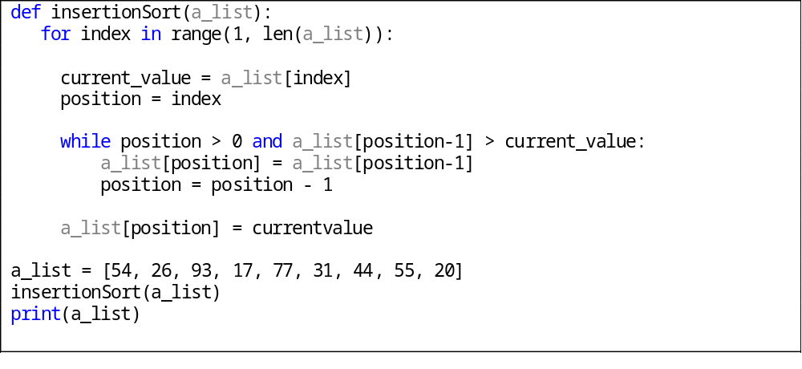

KT 14.2. Dependencies should be made obvious through the use of good routine names, parameter lists, comments, and—if the code is critical enough—housekeeping variables.
Câu lệnh cần được thể hiện rõ ràng bằng cách sử dụng tốt tên đoạn chương trình, danh sách tham số, chú thích, và nếu chương trình cần sự chặt chẽ, ta có thể sử dụng các biến trạng thái.
- Đặt tên chương trình để câu lệnh là rõ ràng, gợi nhớ tính thứ tự.
Ví dụ: ComputeMonthly();
ComputeQuarterly();
ComputeYearly();
Tính toán hằng quý chỉ được thực hiện sau khi tính toàn hằng tháng, tính toàn hằng năm chỉ thực hiện sau khi thực hiện tính toán quý.

- Sử dụng tham số để câu lệnh rõ ràng
Ví dụ:
Thay vì:
InitializeExpenseData ();
ComputeMarketData ();
ComputeSalesData ();
ComputeTravelData ();
ComputePersonalData ();
DisplayExpenseSummary ();

Ta sử dụng tham số expenseData làm tham số chung. Do sự dùng chung tham số giúp người đọc hiểu rằng việc sắp xếp theo thứ tự là quan trọng:
InitializeExpenseData (expenseData);
ComputeMarketData (expenseData);
ComputeSalesData (expenseData);
ComputeTravelData (expenseData);
ComputePersonalData (expenseData);
DisplayExpenseSummary (expenseData);

- Sử dụng comment để giải thích thứ tự chạy của chương trình.
- Sử dụng các biến trạng thái và các đoạn chương trình xử lý lỗi.
Ví dụ: Khi tạo một đối tượng, ta khởi tạo biến isInitialized = false. Sau đó trong hàm InitializeData(), ta gán isInitialized = true. Các hàm sử dụng đối tượng sau đó, sẽ kiếm tra giá trị của isInitialized là true hay false, và chỉ thực hiện khi giá trị đó là true.
Ví dụ: trong quick_sort.py
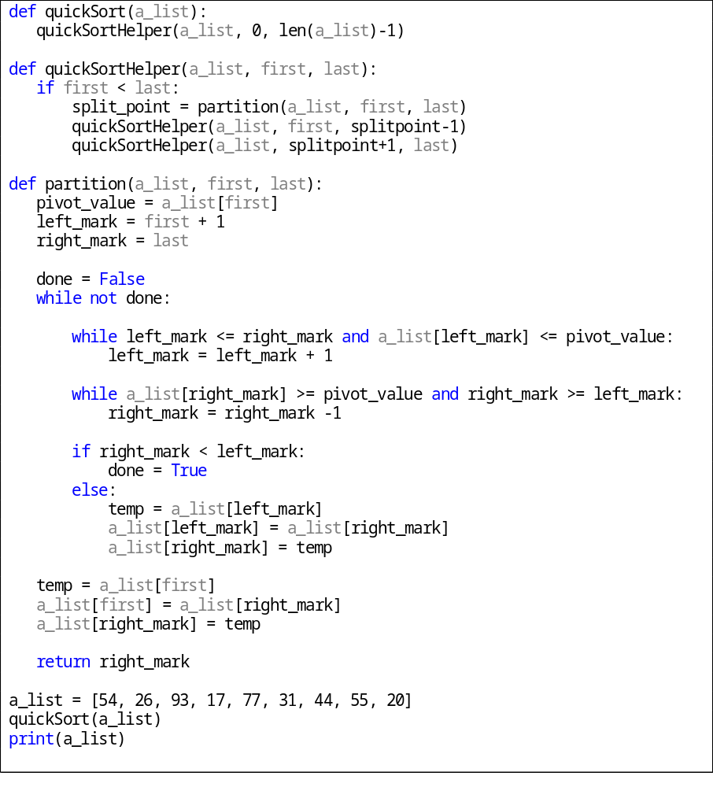

KT 14.3. If code doesn't have order dependencies, keep related statements as close together as possible
Nếu đoạn mã không có sự sắp xếp câu lệnh, gom các ý liên quan gần nhất có thể.
- Tạo code để đọc từ trên xuống dưới
- Gom những biến, đọan chương trình lại có liên quan lại với nhau.
- Giảm thiểu thời gian sống của biến. Khoảng cách giữa tham chiếu đầu tiên và cuối cùng cho một biến phải được giữ ở mức tối thiểu. Điều này làm giảm khả năng lỗi khởi tạo.
- Gom những ý liên quan một cách logic. Nếu câu lệnh liên quan về dữ liệu hay mục đích, giữ chúng gần nhau.
Khi cần xem xét một giá trị, chúng ta phải xem xét chúng từ lúc khởi tạo đến lúc kết thúc. Nếu khoảng cách giữa lần tham chiếu đầu tiên và cuối cùng lớn, thời gian sống của biến lớn, người đọc sẽ phải lần theo gần như toàn bộ chương trình.
Ví dụ 1 chương trình đơn giản gồm việc khởi tạo 3 biến, xử lý 3 biến, in giá trị, giải phóng biến và 3 biến này không có mối quan hệ gì. Thay vì cùng khởi tạo, cùng xử lý, chúng ta có thể chia ra thành 3 khối chương trình, thực hiện lần lượt tường biến
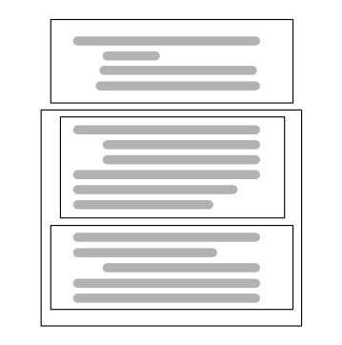
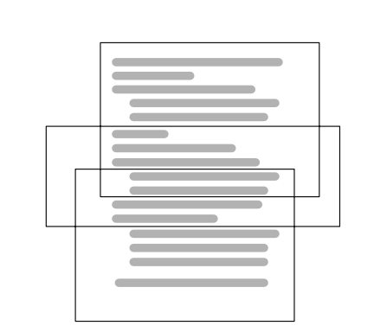
Ví dụ : một phần trong quick_sort.py
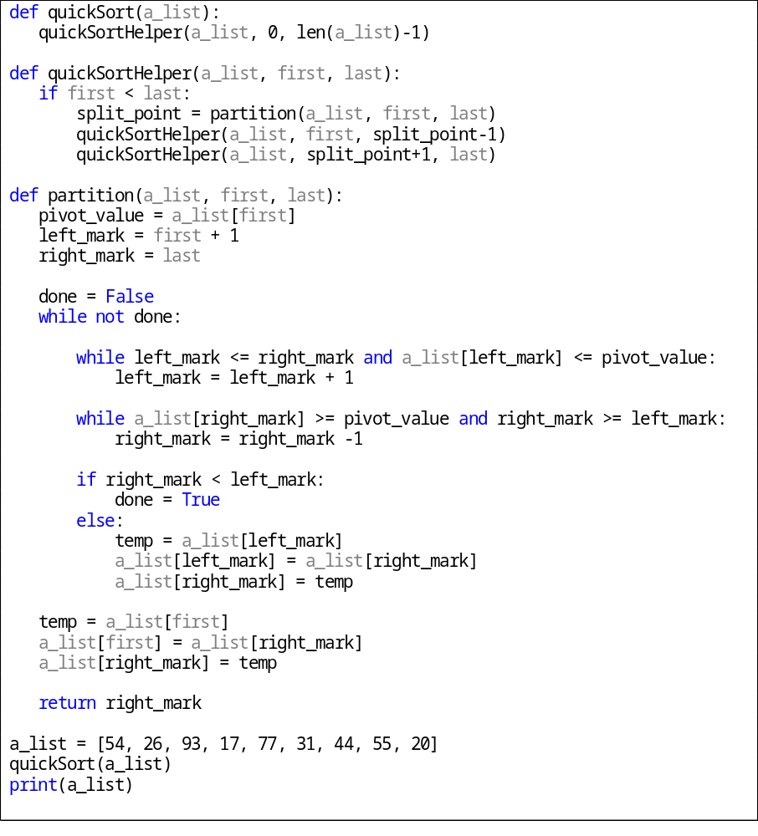

I.2. Sử dụng chương 15 – Sử dụng câu lệnh If-Then

KT 15.1. For simple if-else statements, pay attention to the order of the if and else clauses, especially if they process a lot of errors. Make sure the nominal case is clear.
Đối với câu đơn if-else, chú ý đến thứ tự của if và else, đặc biệt là nếu chúng xử lý rất nhiều lỗi. Hãy chắc chắn rằng các trường hợp danh nghĩa là rõ ràng.
- Vạch ra đường thực hiện thông thường trước rồi mới đặt câu lệnh điều kiện cho trường hợp bất thường, điều này cần thiết cho việc dễ đọc mã nguồn cũng như thực thi.
- Với các câu điều kiện so sánh >, >=, <, <=, hãy đảm bảo khi điều kiện = xảy ra thì rẽ nhánh hợp lí.
- Đưa trường hợp ta mong chờ sẽ thực hiện (trường hợp bình thường) sau câu lệnh if hơn là else, điều này thoả mãn nguyên tắc đưa kết quả từ quyết định gần nhất có thể với quyết định.
- Tránh sử dụng câu lệnh if rỗng (null if), sử dụng chú thích giúp người đọc dễ hiểu câu điều kiện.
- Hãy xem xét các mệnh đề khác. Nếu bạn nghĩ rằng bạn cần một câu lệnh đơn giản if, xem xét xem bạn không thực sự cần một lệnh if-then-else.
- Kiểm tra các mệnh đề else: Khi kiểm tra code, bạn có thể nghĩ rằng mệnh đề chính, if, là tất cả những gì cần phải được kiểm tra, tuy nhiên cũng cần kiểm tra mệnh đề else.
- Kiểm tra sự đảo ngược của lệnh if và else.

Ví dụ : Thuật toán sắp xếp Bubble sort. Trong bubble_sort.py
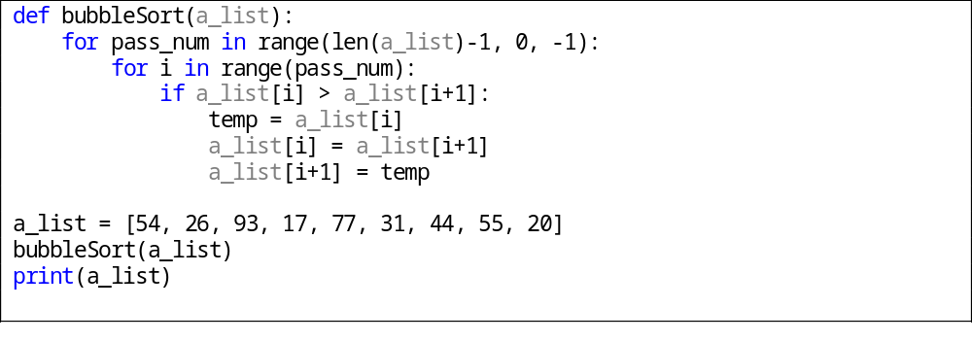

KT 15.2. For if-then-else chains and case statements, choose an order that maximizes read-ability.
Cần đặt thứ tự sao cho chuỗi if-then-else là dễ đọc nhất. Để câu lệnh dễ đọc, trước hết phải tối giản các điều kiện trong mệnh đề if.
- Sử dụng các hàm boolean thay vì dùng kết hợp các câu lệnh and, or phức tạp.
- Đưa trường hợp thường được thực hiện nhất lên đầu tiên.
- Hãy chắc chắn rằng tất cả các trường hợp đều được kiểm tra
- Sử dụng switch case thay vì chuỗi if-else phức tạp. Tuy nhiên python không hỗ trợ kiểu này.
Ví dụ trong thuật toán Selection sort.
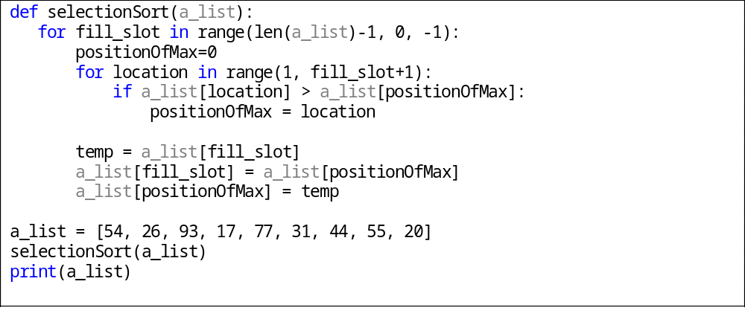

KT 15.3. To trap errors, use the default clause in a case statement or the last else in a chain of if-then-else statements.
Bẫy lỗi, sử dụng các mệnh đề ngầm định trong một mệnh đề lệnh hoặc cuối trong một chuỗi các câu lệnh if-then-else. Điều này đảm bảo chương trình có thể ứng phó với mọi giá trị có thể có của biến.
Ví dụ: trong đoạn code sau, file 15-3.py

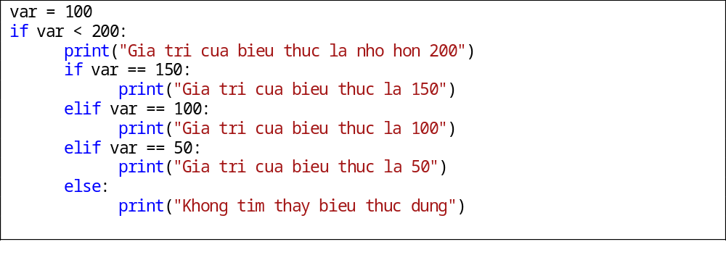

KT 15.4. All control constructs are not created equal. Choose the control construct that's most appropriate for each section of code.
Tất cả các cấu trúc điều khiển không được tạo ra với vai trò như nhau. Cần chọn cấu trúc điều khiển mà là thích hợp nhất.
Ví dụ ta chỉ sử dụng switch – case cho những trường hợp biến case đơn giản (char, số)

I.3. Sử dụng chương 16 – Vòng lặp

KT 16.1. Loops are complicated. Keeping them simple helps readers of your code.
Vòng lặp khá phức tạp, giữ cho vòng lặp đơn giản để giúp người đọc dễ đọc code hơn:
Lựa chọn loại vòng lặp phù hợp
- Vòng lặp đếm được chạy với số lần lặp cụ thể.
- Vòng lặp ước lượng liên tục không thể biết được số vòng lặp sẽ thực hiện mà phải kiểm tra tính kết thúc trên mỗi chu kỳ.
- Vòng lặp vô hạn thực hiên mãi mãi từ khi bắt đầu. Vi dụ: Hệ thống nhúng trong máy tạo nhịp tim.
+ Các loại vòng lặp khác nhau được phân biệt bằng vị trí của câu lệnh kiểm tra sự kết thúc vòng lặp
+ Các loại vòng lặp cũng được phân biệt bằng độ linh hoạt của chúng. Độ linh hoạt là việc các vòng lặp sẽ chạy trong một số lần nhất định hay phải kiểm tra sự kết thúc trong mỗi chu kỳ.
Sử dụng comment để làm rõ các dòng lệnh phức tạp
Ví dụ trong 16-1.py:

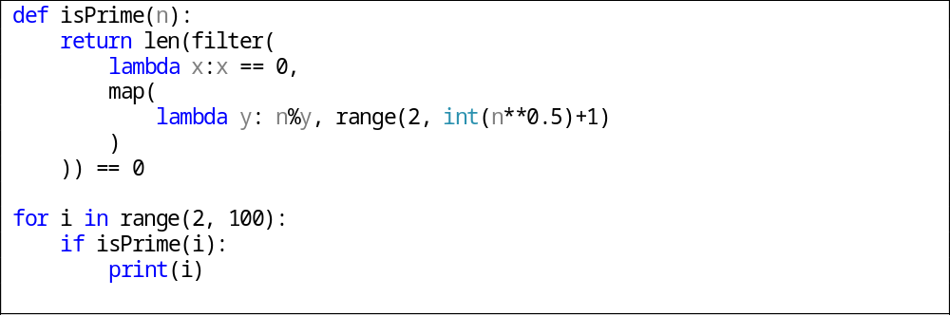

KT 16.2. Techniques for keeping loops simple include avoiding exotic kinds of loops, minimizing nesting, making entries and exits clear, and keeping housekeeping code in one place.
Kĩ thuật để giữ vòng lặp đơn giản bao gồm tránh các loại vòng lặp khác lạ, tối giản hóa các vòng lặp lồng nhau, làm cho khởi tạo và thoát vòng lặp rõ rang và giữa cho housekeeping code ở một ví trí:
- Minimizing nesting:
+ Độ dài vòng lặp có thể được đo bởi số dòng code hay độ sâu của nesting (nest như là một cấu trúc với các vòng lồng vào nhau liên tiếp)
+ Các nghiên cứu đã chỉ ra rằng khả năng của chương trình để hiểu một vòng lặp có thể bị sai khác khi vượt quá 3 vòng lặp lồng nhau. Vì vậy nên giới hạn nesting ở 3 vòng lặp.
+ Có thể tối giản hóa nesting bằng cách dùng câu lệnh break hoặc các cấu trúc điều khiển.
Ví dụ: Giới hạn ở nesting ở 2 vòng lặp và dùng câu lệnh break để làm tối giản hóa chương trình, trong 16-2-nesting.py:
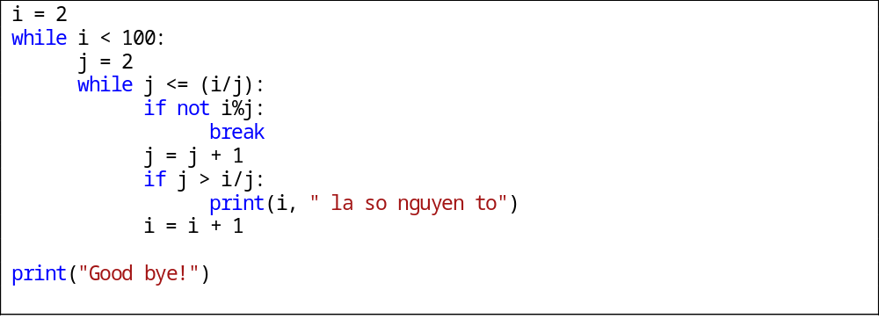
- Making entries clearly:
+ Truy cập vòng lặp chỉ tại một vị trí: Sự đa dạng của cấu trúc điều khiển vòng lặp cho phép kiểm tra sự kết thúc vòng lặp tại đầu, cuối hoặc giữa vòng lặp, cho phép truy nhập vòng lặp từ đỉnh mọi lúc, không cần thiết phải truy cập từ nhiều địa điểm.
+ Đặt giá trị khởi tạo cho các biến dùng trong vòng lặp trước vòng lặp:
Việc làm này giúp cho tránh xảy ra lỗi khi chúng ta cần thiết phải copy hoặc di chuyển vòng lặp tới một vị trí khác trong mã nguồn. Hơn nữa, khi kích thước chương trình lớn, việc đặt cách lệnh khởi tạo trước vòng lặp mà nó liên kết giúp cho việc thay đổi nó dễ dàng, nhanh chóng hơn, người lập trình không phải vất vả tìm kiếm.
Ví dụ: Trong 16-2-entries.py:
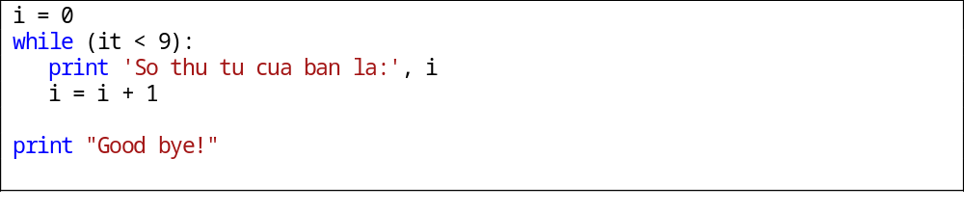
+ Đừng sử dụng một vòng lặp for khi vòng lặp while thích hợp hơn
+ Sử dụng vòng lặp for và while cho vòng lặp vô hạn
- Making exits clearly:
+ Đảm bảo là vòng lặp sẽ kết thúc.
+ Làm điều kiện thoát khỏi vòng lặp thất rõ ràng: Để làm được điều này ta nên dùng 2 quy tắc sau:
  - Đặt tất cả các điều kiện thoát khỏi vòng lặp tại 1 ví trí.
  - Dùng chú thích giúp cho việc đọc hiểu dễ dàng hơn.

- Keep housekeeping code in one place:
+ “Loop housekeeping” là những biểu thức ví dụ như i = i + 1, đây là những biểu thức mà mục đích của nó không phải là biểu thức làm việc của vòng lặp mà nó dùng để điều khiển vòng lặp.The housekeeping nên được đặt đúng chỗ, thường ta sẽ đặt lúc bắt đầu vòng lặp hoặc đặt lúc kết thúc một vòng lặp
+ Thông thường, những biến mà ta khởi tạo trước vòng lặp sẽ là những biến ta sẽ dùng để thực hiện housekeeping.
Ví dụ: Trong 16-2-housekeeping.py
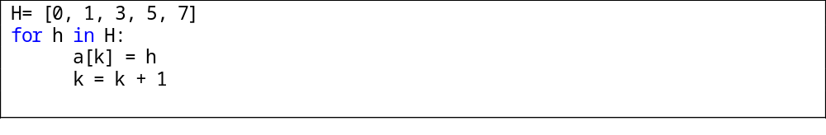

KT 16.3. Loop indexes are subjected to a great deal of abuse. Name them clearly, and use them for only one purpose.
Chỉ số vòng lặp bị lạm dụng rất nhiều. Đặt tên chúng rõ ràng và chỉ dùng cho một mục đích duy nhất.
- Một số quy tắc cho việc dùng biến chỉ số vòng lặp:
+ Dùng loại biến đếm hay biến thứ tự cho cả mảng và vòng lặp.
+ Biến đếm nên là các giá trị nguyên không nên là giá trị dấu phẩy động
Ví dụ: trường hợp cộng 1.0 với 26,742,897.0 được 26,742,897.0 thay vì 26,742,898.0. Và điều này có thể sẽ dần tới vòng lặp bị lặp vô hạn.
+ Dùng biến có tên mang nghĩa rõ ràng, giúp việc đọc dễ dàng hơn
Thông thường đối với các vòng lặp có 1 hoặc 2 mức, chúng ta sử dụng các biến chỉ số i, j hoặc k cho vòng lặp vì nó đơn giản. Nhưng khi với 3 vòng lặp lồng nhau thì việc dùng i, j, k có thể dẫn đến nhầm lẫn trong các chương trình lớn.
Ví dụ: Trong 16-2-nesting.py

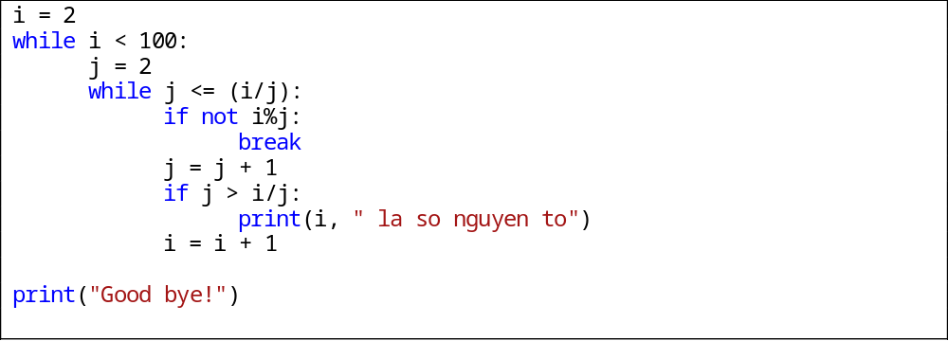
Đây là ví dụ về cách đặt tên các chỉ số rõ ràng:
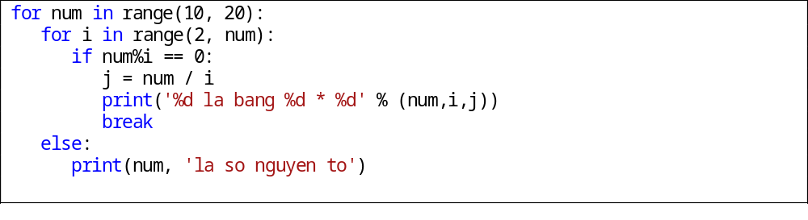
- Việc dùng tên mang nghĩa rõ ràng ngoài việc giúp dễ đọc còn giúp tránh nhầm lẫn việc dùng lại 1 chỉ số 2 lần.
- Giới hạn miền làm việc của biến chỉ số chỉ thực hiện trong vòng lặp của nó, hay là mỗi biến chỉ số chỉ phục vụ cho một mục đích

Ví dụ:
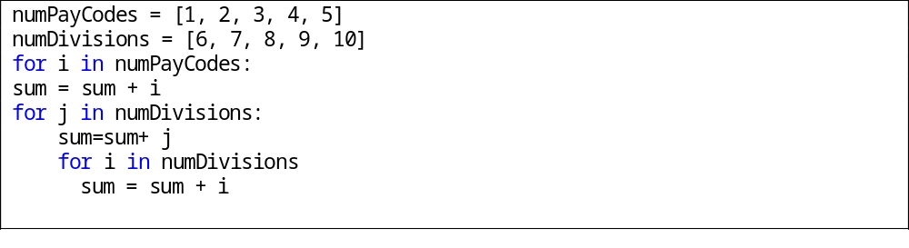

KT 16.4. Think through the loop carefully to verify that it operates normally under each case and terminates under all possible conditions.
Nghĩ xuyên suốt vòng lặp thật kỹ càng để kiểm chứng rằng nó đã hoạt động bình thường tỏng mọi trường hợp kết thúc nó dưới mọi điều kiện có thể.
- Bảo đảm rằng vòng lặp kết thúc được. Điều này là nguyên tắc cơ bản. Chúng ta phải đóng vai trò là vòng lặp, cho chạy thử 1 số lần lặp, suy nghĩ tất cả các trường hợp có thể xảy ra, điểm kết thúc và nhưng trường hợp ngoại lệ. Việc làm này đòi hỏi tư duy của người lập trình.
- Viết các kiều kiện kết thúc vòng lặp một các rõ ràng, rành mạch.
- Không dùng lại các biến chỉ số của vòng lặp for để kết thúc vòng lặp.
- Kiểm tra điểm kết thúc. Để kiểm tra liệu vòng lặp có kết thúc với kết quả đúng như mong muốn hay không thông thường người lập trình kiểm tra với trường hợp giá trị đầu tiên, sau đó 1 giá trị được chọn ở giữa, và cuối cùng là trường hợp giá trị cuối cùng. Nếu gặp một trường hợp đặc biệt mà khác với trường hợp đầu tiên hoặc cuối cùng, ta nên kiểm tra lại nó. Nếu biểu thức vòng lặp chứa là phực tạp, ta có thể sử dụng máy tính để tính toán biểu thức.
- Việc tìm các trường hợp phát sinh dựa vào mạch tư duy logic của người lập trình cho nên kĩ thuật này đòi hỏi người lập trình phải suy nghĩ thấu đáo, tính toán cẩn thận đảm bảo vòng lặp kết thúc đúng như mong muốn.

I.4. Sử dụng chương 17 – Các cấu trúc điều khiển khác

KT 17.1. Multiple returns can enhance a routine's readability and maintainability, and they help prevent deeply nested logic. They should, nevertheless, be used carefully.
Chương trình con có nhiều lần trả về (return) có thể nâng cao khả năng đọc và bảo trì của chương trình và giúp ngăn ngừa sai sót trong những đoạn lồng nhau. Dù vậy, chúng nên được sử dụng cẩn thận.
- Sử dụng return để làm cho chương trình con dễ đọc hơn.
- Sử dụng lệnh thoát (return) sớm để đơn giản các quá trình xử lý lỗi phức tạp:
Thay vì sử dụng 1 loạt các câu lệnh if lồng nhau để kiểm tra điều kiện, ta có thể return ngay khi 1 điều kiện không thỏa mãn.
Ví dụ: trong binary_search.py
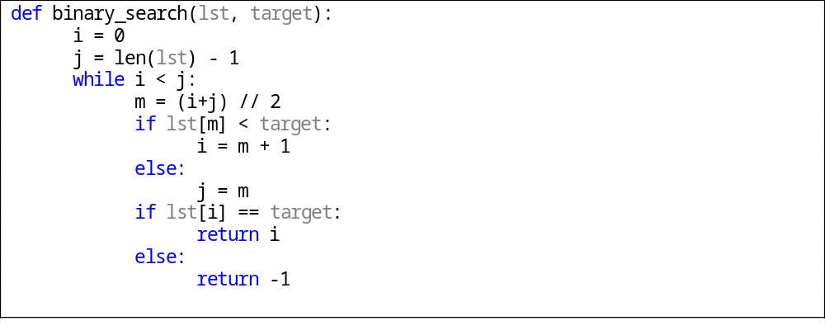
Như ví dụ trên ta thấy việc có nhiều lần trả về giúp chương trình dễ đọc hơn và dễ debug khi chương trình xảy ra lỗi hoặc sai kết quả.
- Ngoài ra còn giúp ngăn chặn việc xảy ra lỗi khi chạy chương trình.
- Cần phải thận trọng khi dùng return, cần phải xét hết tất cả trường hợp.
Tuy nhiên cũng không nên lạm dụng return, chỉ sử dụng nó khi chúng giúp các dòng code dễ đọc hơn. Vì giả sử nếu đọc code từ dưới lên và người đọc không ý thức được ở trên còn có các lệnh return khác sẽ dẫn đến sự khó khăn trong việc hiểu đoạn code.

KT17.2. Recursion provides elegant solutions to a small set of problems. Use it carefully, too.
- Thuật toán đệ quy là thuật toán được phát triển dựa trên phương pháp chia để trị, chia hàm thành các hàm con giải quyết vấn đề nhỏ hơn bằng cách tự gọi đến chính mình với đầu vào kích thước nhỏ hơn.
- Việc sử dụng thuật toán đệ quy là thuận tiện khi các bài toán con dễ xử lý trong khi bài toán lớn lại phức tạp.
- Đệ quy không phải lúc nào cũng đem lại lợi ích, đặc biệt là về mặt thời gian. Nhưng bù lại nó là 1 trong những cách tiếp cận hết sức hiệu quả và đơn giản đối với 1 bài toán khó, và người ngoài khi đọc code cũng sẽ dễ dàng nắm bắt được ý tưởng của người lập trình.
Minh họa bằng ví dụ bài toán Tháp Hà Nội. Trong merge_sort.py:
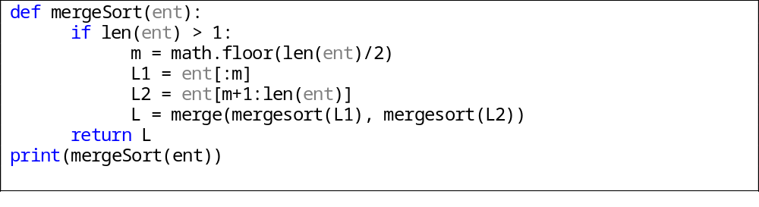Một số chú ý khi dùng đệ quy:
- Đảm bảo rằng đệ quy phải có điểm dừng: Ở ví dụ Merge Sort, trước khi bắt đầu hàm sẽ có 1 lệnh yêu cầu rẽ nhánh if (left >= right) để kiểm tra có nhiều hơn 1 phần tử hay không, nếu có cho tiếp tục thực hiện đệ quy, nếu không thì ngay lập tức trả lại phần tử đó.
- Tránh sử dụng đệ quy xoay vòng (cyclic recursive): Việc sử dụng đệ quy xoay vòng (A gọi B, B gọi C, C gọi A) là rất nguy hiểm, dễ dẫn đến chạy vô hạn.
- Chú ý tới stack: cần phải để ý đến stack đang dùng còn đủ dung lượng không vì đệ quy rất khó kiểm soát stack.
- Không nên sử dụng đệ quy cho việc tính giai thừa, số Fibonacci nói riêng hay các bài toán mà có thể giảiquyết dễ dàng bằng vòng lặp nói chung.

KT17.3. In a few cases, gotos are the best way to write code that's readable and maintainable. Such cases are rare. Use gotos only as a last resort.
Trong 1 số trường hợp, goto lại là cách tốt nhất để biến mã nguồn trở nên dễ đọc, dễ tiếp cận hơn. Tuy nhiên trường hợp này thường rất hiếm xảy ra, nhìn
chung “goto” nên được xem như là phương án cuối cùng khi thực sự cần thiết.

II. Tổng hợp kỹ thuật làm việc với các biến

II.1. Sử dụng Chương 10 – Các kỹ thuật chung làm việc với biến:

KT10.1. Data initialization is prone to errors, so use the initialization techniques described in this chapter to avoid the problems caused by unexpected initial values.
Khởi tạo dữ liệu dễ bị lỗi, vì vậy sử dụng các kỹ thuật khởi tạo mô tả trong chương 10 để tránh các vấn đề gây ra bởi các giá trị ban đầu không mong đợi.
1. Các kiểu dữ liệu là rất đa dạng, việc khai báo và khởi tạo biến cần đúng kỹ thuật để thuận cho việc viết code.
2. Các kỹ thuật khởi tạo biến:
- Khai báo biến ngay khi nó được khởi tạo.
Ví dụ:
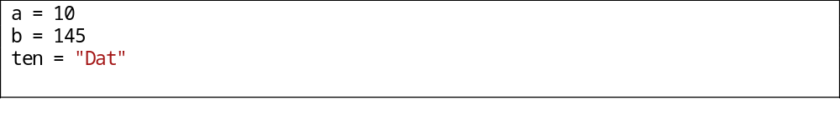 - Khởi tạo biến gần nơi nó được dùng lần đầu.
- Đặc biệt chú ý đến biến đếm và tính tổng: Các biến i, j, k, sum, và total thường dùng để đếm hoặc tính tổng. Một lỗi thường gặp là quên thiết lập lại biến trước lần sử dụng tiếp theo.
- Khởi tạo dữ liệu con của một lớp trong constructor của nó.
- Kiểm tra nếu cần thiết phải khởi tạo lại giá trị biến.
- Khởi tạo hằng số có tên chỉ một lần, khởi tạo các biến với mã thực thi
- Có thể sử dụng tính năng tự động khởi tạo giá trị của trình biên dịch (nếu có)
- Tận dụng lợi thế của các cảnh báo của trình biên dịch:
Một số trình biên dịch sẽ cảnh báo nếu biến chưa khởi tạo.
- Kiểm tra các thông số đầu vào về tính hợp lệ:
- Trước khi khởi tạo giá trị cho biến cần kiểm tra giá trị đó có hợp lệ không.
- Sử dụng bộ kiểm tra truy cập bộ nhớ (memory-access checker) để kiểm tra con trỏ không hợp lệ.
- Khởi tạo bộ nhớ làm việc ngay đầu chương trình.

KT10.2. Minimize the scope of each variable. Keep references to a variable close together. Keep it local to a routine or class. Avoid global data.
Tối giản hóa phạm vi của mỗi biến. Giữ cho các tham chiếu gần một biến cùng nhau. Giữ biến tại địa phương ở một chương trình con hoặc lớp. Tránh dữ liệu toàn cục.
- Địa phương hóa các tham chiếu đến các biến. Nên sử dụng biến địa phương (chương trình con hay lớp), hạn chế biến toàn cục. Điều này giúp dễ kiểm soát chương trình và tránh các lỗi do dùng chung biến.
- Trong chương trình, các code mới có thể được thêm vào vô tình thay thế các biến hoặc một ai đó đọc chương trình có thể quên giá trị của biến mà nên nhớ. Vì vậy cần phải địa phương hóa các tham chiếu đến biến bằng cách giữ chúng gần nhau.Khi giữ biến tham chiếu gần đến biến gần nhau, cho phép người đọc tập trung một khu vực nhất định vì vậy nâng cao tính dễ đọc của chương trình.
- Những hướng dẫn chung về giảm thiểu phạm vi biến:
- Khởi tạo các biến được sử dụng trong vòng lặp ngay trước khi vào vòng lặp thay vì ở đầu những chương trình con chứa vòng lặp.Việc làm này giúp khi sửa đổi các vòng lặp, ta sẽ nhớ sửa đổi tương ứng các biến để khởi tạo vòng lặp.
Ví dụ:
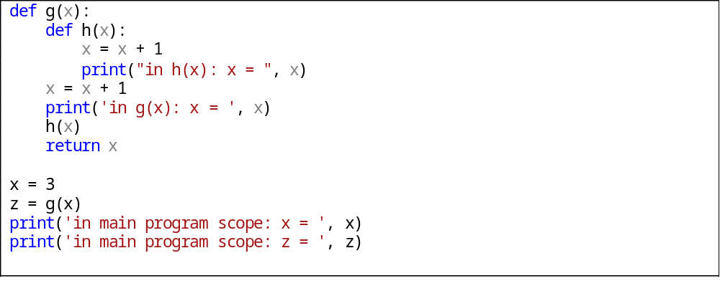
-Không gán giá trị cho biến cho đến khi biến được sử dụng. Ví dụ:
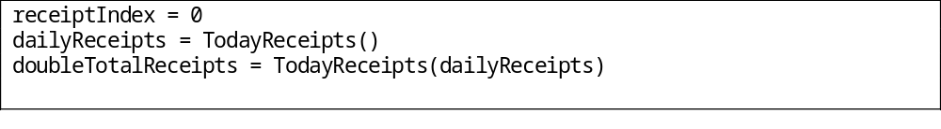
- Nhóm các câu lệnh có liên quan lại với nhau.
- Bắt đầu với phạm vi của biến nhỏ nhất, mở rộng khi cần thiết.
Mở rộng phạm vi biến dễ hơn là thu hẹp phạm vi

KT10.3. Keep statements that work with the same variables as close together as possible.
Giữ cho các câu lệnh làm việc với các biến giống nhau gần nhau nhất có thể:
- Việc giữ các câu lệnh làm việc với các biến giống nhau ở gần nhau giúp dễ dàng kiểm soát giá trị của biến đó hơn.
Ví dụ:
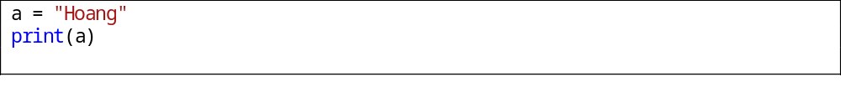 Biến a được sử dụng ngay sau khi khai báo.
- Giữ thời gian sống(live time) của biến ngắn nhất có thể. Thời gian sống của một biến khi được tham chiếu đến lần đầu tiên và kết thúc tại câu lệnh cuối cùng mà nó được tham chiếu đến.
Ví dụ:
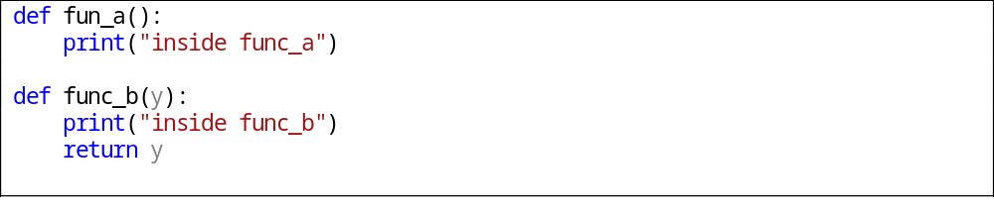
- Giữ khoảng cách giữa các biến giống nhau(span) ngắn nhất có thể. Khoảng cách giữa các biến giống nhau(span) là số câu lệnh nằm giữa chúng.
- Việc giữ thời gian sống(live time) và span ngắn nhất có thể chính là việc giữ các câu lênh làm việc với các biến giống nhau ở gần nhau nhất có thể. Điều này sẽ làm giảm các lỗ hổng hoặc là những sự thay đổi không đáng có khi thay thế một biến giữa các nơi mà có ý định thay thế.
- Một ưu điểm nữa là có một bức tranh toàn cảnh về mã nguồn, dễ dàng kiểm soát giá trị, giảm thiểu khả năng khởi tạo sai giá trị.

KT10.4. Early binding tends to limit flexibility but minimize complexity. Late binding tends to increase flexibility but at the price of increased complexity.
Liên kết sớm có xu hướng hạn chế tính linh hoạt nhưng giảm thiểu sự phức tạp. Liên kết muộn có xu hướng tăng tính linh hoạt nhưng lại tăng sự phức tạp lên.
Blind time: thời điểm mà biến và giá trị của nó liên kết với nhau

KT10.5. Use each variable for one and only one purpose.
Sử dụng mỗi biến cho một và chỉ một mục đích.
- Sử dụng mỗi biến cho một và chỉ một mục đích.
Ví dụ:
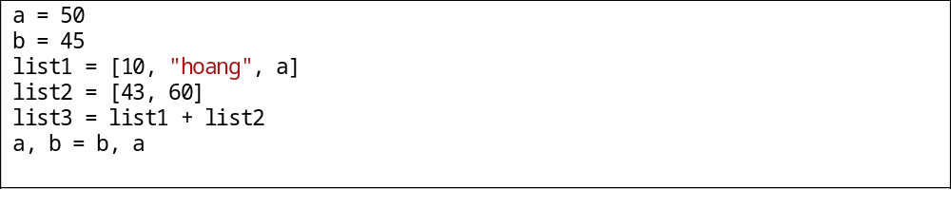
Không nên khai báo biến rồi không sử dụng, việc này gây lãng phí bộ nhớ.

II.2. Sử dụng chương 11 – Kỹ thuật đặt tên biến

KT11.1. Good variable names are a key element of program readability. Specific kinds of variables such as loop indexes and status variables require specific considerations.
Việc đặt tên biến tốt là một yếu tố quan trọng giúp chương trình dễ hiểu hơn. Các loại biến đặc biệt như chỉ số lặp, biến trạng thái yêu cầu sự xem xét cụ thể:
+ Tên biến phải biểu diễn chính xác và đầy đủ nội dung mà biến thể hiện.
+ Độ dài vừa phải. Tên quá ngắn không truyền tải đủ nội dung, tên dài gây khó khăn khi viết và đọc.
+ Các đặc trưng của giá trị tính toán, nếu có, nên đặt ở cuối tên
+ Nên đặt những tên như Count hoặc Index thay vì Num
Tuy nhiên trong những biến cục bộ, ví dụ chỉ tồn tại trong vòng lặp đơn giản, ta có thể đặt là i
Ví dụ minh họa:
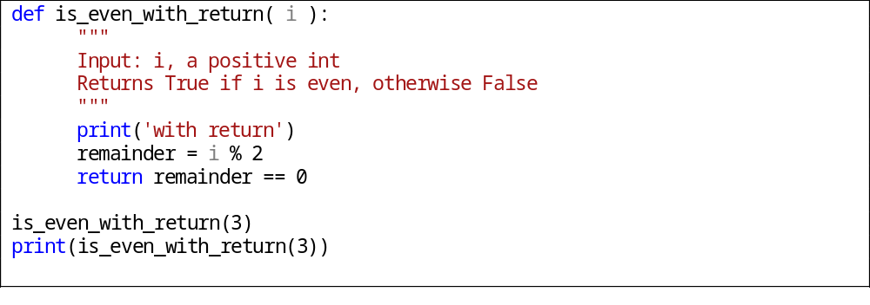

KT11.2. Names should be as specific as possible. Names that are vague enough or general enough to be used for more than one purpose are usually bad names
Tên nên đặt càng cụ thể càng tốt. Tên không tốt là tên mơ hồ hoặc chung chung
- Chỉ số lặp nên có nghĩa (cái gì đó hơn là i, j, hoặc k nếu vòng lặp có nhiều hơn một, hai dòng hoặc lồng nhau)
- Tất cả các biến tạm thời nên được đặt thành cái gì đó có ý nghĩa để dễ phân biệt thay vì tất cả đều được đặt là temp
- Các tên các biến logic được đặt tên sao cho chúng có nghĩa khi chúng là True và rõ ràng
- Loại tên thống kê nên bao gồm tiền tố hoặc hậu tố, ví dụ: Color_ for Color_Red, Color_Green, Color_Blue, ...
- Tên hằng số nên bổ nghĩa cho thực thể thay vì con số gán cho nó
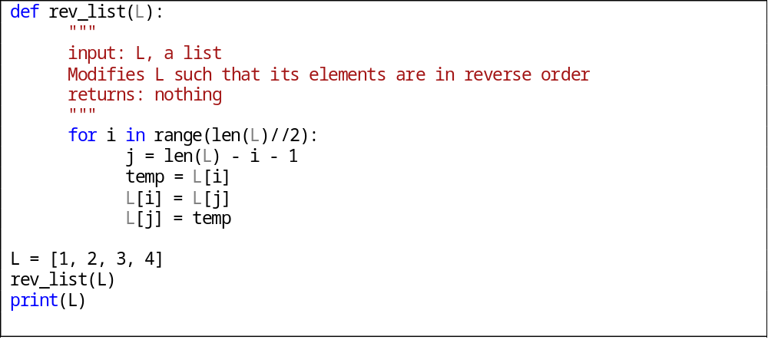

KT11.3. Naming conventions distinguish among local, class, and global data. They distinguish among type names, named constants, enumerated types, and variables
Quy ước đặt tên biến phân biệt giữa địa phương, lớp, và dữ liệu toàn cục. Phải phân biệt tên loại, tên hằng, kiểu thống kê và biến.
- Quy ước quy định đối số truyền vào và thủ tục thi hành chúng
- Quy ước nên càng giống với quy ước chuẩn của ngôn ngữ càng tốt
- Tên nên đặt để dễ đọc
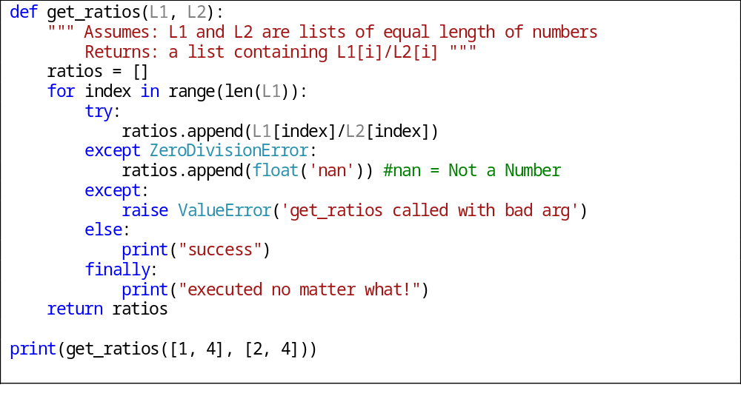

KT 11.4 . Regardless of the kind of project you're working on, you should adopt a variable naming convention. The kind of convention you adopt depends on the size of your program and the number of people working on it.
Tùy thuộc vào quy mô của dự án để chọn quy ước đặt tên cho phù hợp.
Mức độ không chính thức – informal chỉ đơn giản là đặt tên biến có nghĩa:
Không phụ thuộc vào ngôn ngữ:
- Phân biệt rõ ràng tên biến và tên hàm. Chẳng hạn, với tên biến ta viết thường chữ đầu các chữ sau viết hoa (vd: firstIdex, lastIndex,…) , với tên hàm ta viết hoa tất cả các chữ cái đứng đầu từ (vd: ArrayList(), PrintfList() ,…) .
- Phân biệt giữa các lớp và các đối tượng. Biến được đặt tương thích với hàm hoặc cấu trúc sẽ giúp người lập trình linh hoạt hơn trong việc chỉnh sửa hoặc tùy chỉnh lại chương trình mà mình đã viết .
- Phân biệt biến toàn cục bằng tiền tố “g_”
- Phân biệt các loại và biến thông qua " t_ " Prefix cho loại biến.
Ví dụ:int class_Index
value_Element
- Phân biệt các loại và biến thông qua một “tiền tố” cho giá trị biến.
Ví dụ:int rightLenght;
leftLenght
- Phân biệt các loại và biến qua sử dụng tên cụ thể hơn cho các biến.
Ví dụ:lenghtofArrayListA
lenghtofArrayListB
- Đặt tên biến có định dạng để nâng cao tính dễ đọc của chương trình.
Ví dụ, thay vì đặt tên biến theo kiểu lenghtofArrayList
Ta có thể đặt theo kiểu lengh_of_ArrayList
- Sử dụng một số kí hiệu phổ biến cho những biến hay dung trong chương trình.
Hoặc phụ thuộc vào ngôn ngữ cụ thể C, Java hoặc là trộn giữa các ngôn ngữ
Sử dụng các tiền tố chuẩn như Hungarian naming convention

KT 11.5. Abbreviations are rarely needed with modern programming languages. If you do use abbreviations, keep track of abbreviations in a project dictionary or use the standardized prefixes approach.
Quy ước khi dùng biến viết tắt (trang 279 chương 11)
+/ Sử dụng từ viết tắt trong tiếng anh của biến. Trong trường hợp trùng với biến khác thì có thể sử dụng nhiều hơn một kí tự ở đầu để viết tắt biến.Cách viết tắt này được sử dụng rộng rãi tuy nhiên một vài người có thể có cách viết tắt khác.
Ví dụ : a = 45
b = « VietNam »
+/ Tạo ra những tên biến ngắn nhưng vẫn có thể đọc được. Ta có thể tạo ra các tên biến ngắn tốt bằng cách loại bỏ những từ không cần thiết , sử dụng các từ đồng nghĩa ngắn , và sử dụng một số chiến lược viết tắt bất kỳ. Đó là một ý tưởng tốt để làm quen với nhiều kỹ thuật viết tắt bởi vì không có kỹ thuật nào đủ tôt để hoạt động tốt trong mọi trường hợp.
Ví dụ, trong trường hợp chương trình chỉ có một mảng thì thay vì cách kí hiệu
List12=[3,5]
Ta có thể kí hiệu thành
List=[3,5]
Vì khi đọc chương trình nhìn vào vị trí của biến leng người ta có thể biết được nó dung để tính độ dài của mảng A.

+/ Sử dụng chữ viết tắt tiêu chuẩn phổ biến được liệt kê trong từ điển. Hủy bỏ tất cả các nguyên âm ( Máy tính thành cmptr và một số nguyên trở thành intgr . . ) . Giữ chữ cái đầu tiên và cuối cùng của mỗi từ. Sử dụng từ ngữ quan trọng trong tên, lên đến tối đa là ba từ . Bỏ hậu tố -ing , ed . Và hãy chắc chắn không thay đổi ý nghĩa của biến.

+/ Tránh những trường hợp bị nhầm lẫn các biến với nhau do cách kí hiệu gần giống nhau.

KT 11.6. Code is read far more times than it is written. Be sure that the names you choose favor read-time convenience over write-time convenience.
Sức mạnh của việc gọi tên biến (trang 284 chương 11)

+/ Sử dụng những tên biến ngắn nếu có thể. Biến được đọc khi chay chương trình nhiều hơn rất nhiều so với khi viết nó, do vậy nếu tên biến được đọc một cách nhanh chóng sẽ giúp chương trình thực hiện một cách thuận lợi hơn.

+/ Hai rủi ro của người đọc khi đọc một chương trình có nhiều biến viết tắt là anh ta có thể không hiểu nghĩa của biến viết tắt hoặc nhầm lần giữa các biến có cách viết tắt gần giống nhau.
Ví dụ: Từ viết tắt “app” có thể được hiểu là viết tắt của từ “application” nhưng cũng có thể hiểu là “append”.

+/ Việc thiết lập một bảng viết tắt các tên biến khi làm viêc trong một dự án giúp thống nhất cách viết tắt các biến. Mỗi khi người lập trình có ý định viết tắt một biến anh ta phải đưa nó vào bảng từ viết tắt để người khác có thể thống nhất cách viết hoặc có thể hiểu anh ta đang viết gì.

+/ Tránh trường hợp có chữ số trong tên nếu nó không giúp ích cho việc gọi tên biến.

II.3. Các kiểu dữ liệu cơ bản

KT12.1. Working with specific data types means remembering many individual rules for each type. Use this chapter's checklist to make sure that you've considered the common problems.
Làm việc với các kiểu dữ liệu cụ thể nghĩa là phải nhớ nhiều nguyên tắc riêng biệt cho từng kiểu. Sử dụng danh sách kiểm tra của chương này để chắc chắn rằng bạn đã xem xét những vấn đề thông thường.
Dữ liệu số nói chung:
+/ Tránh sử dụng trực tiếp số trong chương trình.
+/ Sử dụng giá trị 0, 1 nếu cần thiết.
+/ Lường trước lỗi chia cho 0.
+/ Chuyển đổi kiểu phải rõ ràng.
+/ Tránh phép so sánh với các kiểu dữ liệu khác nhau.
+/ Để ý các cảnh báo của trình biên dịch.
Số nguyên:
+/ Kiểm tra phép chia số nguyên.
+/ Kiểm tra tràn số nguyên.
+/ Kiểm tra tràn số ở kết quả tức thì.
Số thực dấu phẩy động:
+/ Tránh cộng hoặc trừ trên các số có giá trị khác biệt nhau quá lớn.
+/ Tránh so sánh bằng.
+/ Lường trước lỗi làm tròn.
+/ Kiểm tra ngôn ngữ và thư viện hỗ trợ cho các kiểu dữ liệu cụ thể.
Kí tự và xâu kí tự:
+/ Tránh dùng trực tiếp kí tự hoặc xâu kí tự.
+/ Nắm bắt ngôn ngữ lập trình và môi trường hỗ trợ Unicode như thế nào.
Biến boolean:
+/ Sử dụng biến boolean giúp làm đơn giản các câu lệnh điều kiện
+/ Sử dụng biến boolean để đơn giản hóa các kiểm tra phức tạp.
Hằng số:
+/ Sử dụng hằng số trong khai báo dữ liệu hoặc để giới hạn vòng lặp thay cho sử dụng trực tiếp số
+/ Sử dụng hằng số một cách nhất quán trong suốt chương trình

Ví dụ về tránh sử dụng trực tiếp số trong chương trình và khai báo hằng.
Không nên:
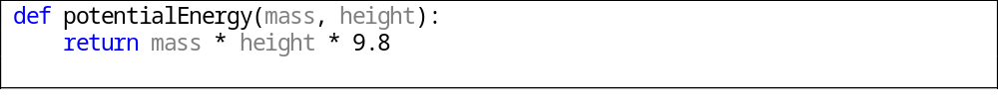
Ta nên khai báo hằng số GRAVITATIONAL_CONSTANT = 9.81
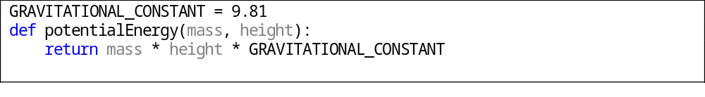
Ví dụ về dấu phẩy động, tránh so sánh bằng. Trong float.py
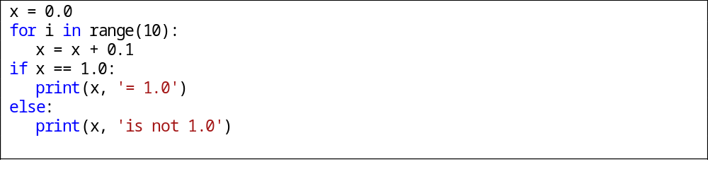
Chương trình sẽ in ra “1.0 is not 1.0”, bởi các bit phía cuối của x không phải là bit 0.

KT 12.2. Creating your own types makes your programs easier to modify and more self-documenting, if your language supports that capability.
Kiểu dữ liệu tự tạo giúp chương trình dễ dàng sửa đổi, nếu ngôn ngữ lập trình hỗ trợ điều này
+/ Tạo kiểu dữ liệu với tên hướng tới chức năng.
+/ Tránh định nghĩa lại các kiểu dữ liệu đã định nghĩa.

Ví dụ trong coordinate.py
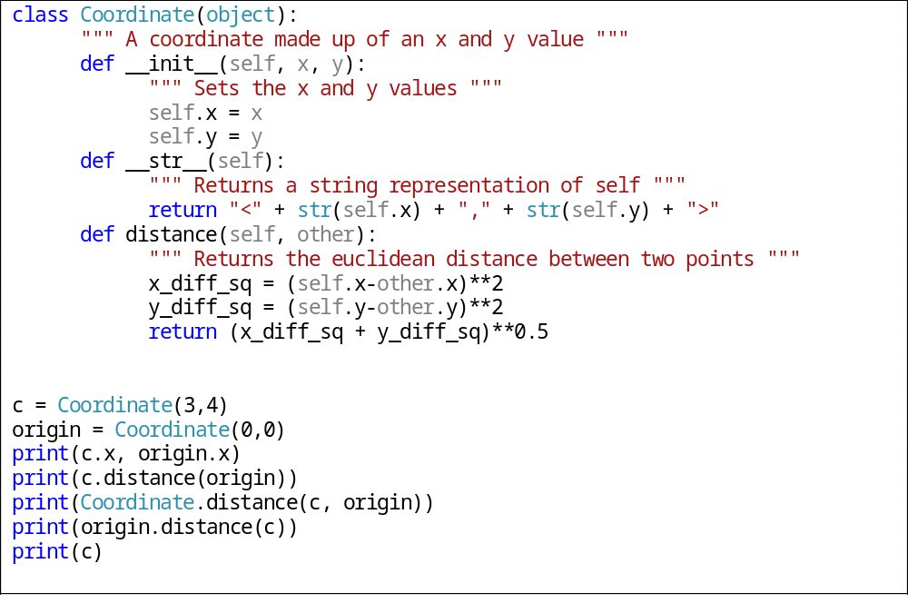

KT 12.3. When you create a simple type using typedef or its equivalent, consider whether you should be creating a new class instead
Khi bạn tạo một kiểu dữ liệu đơn giản, xem xét liệu có nên tạo một class mới.
Trong python, tạo một kiểu dữ liệu mới đồng nghĩa với việc phải tạo class mới.

II.4. Các kiểu dữ liệu đặc biệt

KT13.1. Structures can help make programs less complicated, easier to understand, and easier to maintain
Kiểu dữ liệu cấu trúc có thể giúp chương trình bớt phức tạp, dễ hiểu và dễ bảo trì hơn.
Python không có struct như C, thay vào đó, ta có thể sử dụng Tuples, Lists hoặc Dictionaries, hoặc tạo class mới.

Ví dụ về sử dụng Tuple:
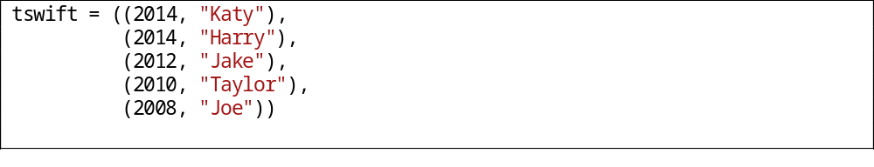
Ví dụ về sử dụng List:
Ví dụ về sử dụng Dictionary:

KT13.2. Whenever you consider using a structure, consider whether a class would work better.
Bất cứ khi nào bạn xem xét sử dụng kiểu dữ liệu cấu trúc, xem xét liệu việc sử dụng class sẽ tốt hơn hay không.
Python không hỗ trợ kiểu dữ liệu cấu trúc (struct), phải sử dụng class.

KT 13.3 Pointers are error-prone. Protect yourself by using access routines or classes and defensive-programming practices.
Con trỏ dễ gây lỗi. Sử dụng chương trình con hoặc class và luyện tập lập trình phòng ngừa.
Python không có con trỏ, thay vào đó là khái niệm tham chiếu.
Ví dụ:
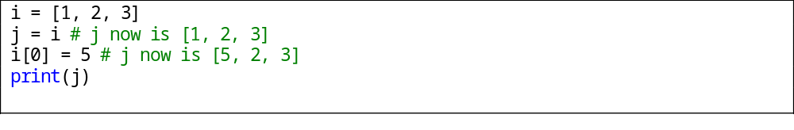

KT13.4. Avoid global variables, not just because they're dangerous, but because you can replace them with something better.
Tránh biến toàn cục vì chúng dễ dàng gây ra lỗi và bạn có thể thay thế chúng bằng 1 vài thao tác khác.
Vấn đề chung với dữ liệu toàn cục:
- Vô tình thay đổi dữ liệu toàn cục.
- Vấn đề tái sử dụng đoạn code với biến toàn cục.
- Lỗi khi thứ tự ưu tiên của biến toàn cục không rõ ràng. Lỗi này thường phụ thuộc vào chương trình dịch
- Khi viết một chương trình lớn có vài trăm dòng code, cần phải chia chương trình thành nhiều phần nhỏ để dễ quản lý. Nếu sử dụng biến toàn cục, khi thay đổi 1 phần trong đó nó sẽ có thể ảnh hưởng tới toàn bộ phần còn lại.

Ví dụ: Trong 13-4.py
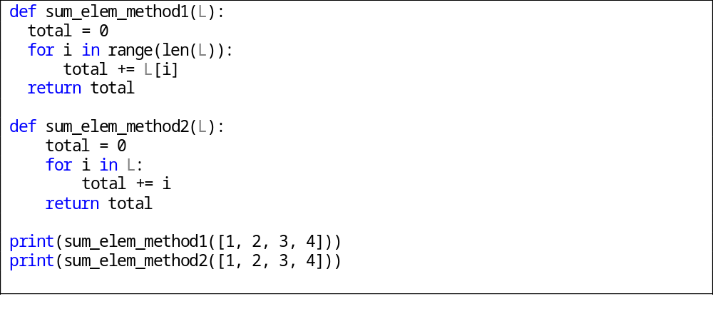
Ở đây hoàn toàn có thể sử dụng total là biến toàn cục, nhưng không nên.

KT13.5. If you can't avoid global variables, work with them through access routines. Access routines give you everything that global variables give you, and more.
Nếu bạn không thể tránh biến toàn cục, hãy sử dụng các chương trình con. Các chương trình con cung cấp mọi chức năng mà biến toàn cục có thể và nhiều hơn nữa.
Lợi ích từ việc sử dụng chương trình con:
- Có thể kiểm soát dữ liệu tốt hơn. Nếu cần thiết phải sửa 1 đoạn code nào đó thì sẽ không cần thiết phải kiểm tra toàn bộ chương trình.
- Đảm bảo rằng tất cả các tham chiếu tới biến đều được chặn bảo vệ.
- Che giấu thông tin.
- Làm cho chương trình dễ nhìn và dễ hiểu hơn.

Ví dụ: Trong 13-5.py sử dụng các chương trình con:

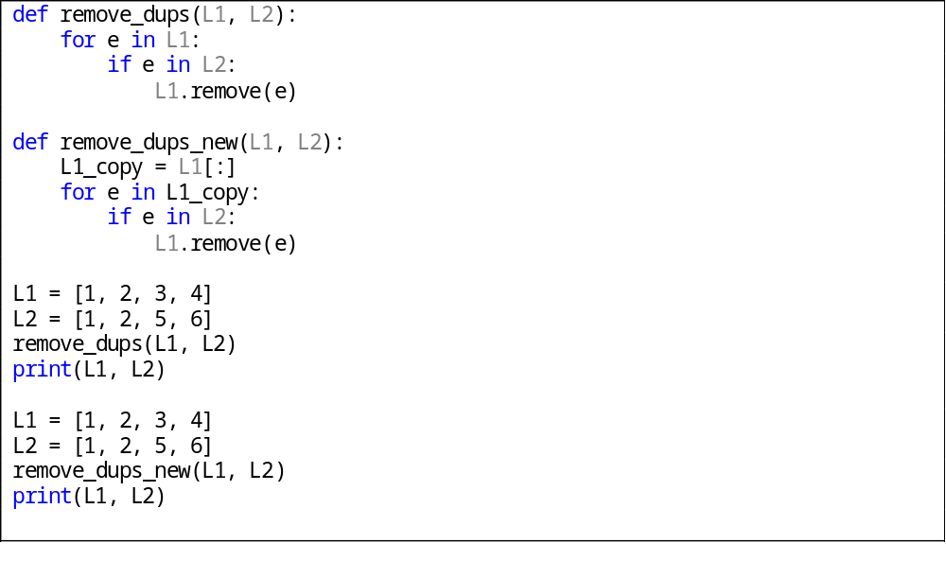

III. Tổng hợp kỹ thuật xây dựng chương trình, hàm, thủ tục.

III.1. Sử dụng Chương 5 – Các kỹ thuật thiết kế chương trình phần mềm Design in Construction

KT 5.1. Software's Primary Technical Imperative is managing complexity. This is greatly aided by a design focus on simplicity.
Kĩ thuật bắt buộc căn bản của phần mềm là quản lí sự phức tạp. Điều này được hỗ trợ bằng cách thiết kế tập trung vào sự đơn giản.
- Các khó khăn cơ bản và tình cờ
- Tầm quan trọng của quản lí sự phức tạp
  - Phần lớn các dự án thất bại do không kiểm soát được sự phức tạp. Phức tạp không phải là đặc tính mới của phát triển phần mềm. Mục tiêu của tất cả kĩ thuật thiết kế phần mềm là khiến những vấn đề phức tạp thành những mảnh đơn giản.
- Cách giải quyết sự phức tạp
  - Có 3 nguồn gây tốn kém, thiết kế không hiệu quả:
    - Một giải pháp phức tạp cho vấn đề đơn giản
    - Một giải pháp đơn giản, không chính xác cho một vấn đề phức tạp.
    - Một giải pháp không thích hợp, phức tạp cho một vấn đề phức tạp.
  - Cách giải quyết:
    - Tính đơn giản được thực hiện bằng hai cách chung: giảm thiểu sự phức tạp cơ bản mà não bất kì ai cũng có thể đối phó trong một thời điểm
    - Giữ sự phức tạp ngẫu nhiên khỏi phát sinh không cần thiết.

Ví dụ: Trong heapsort.py. Tổ chức chương trình thành nhiều chương trình con giúp chương trình dễ quản lý hơn.
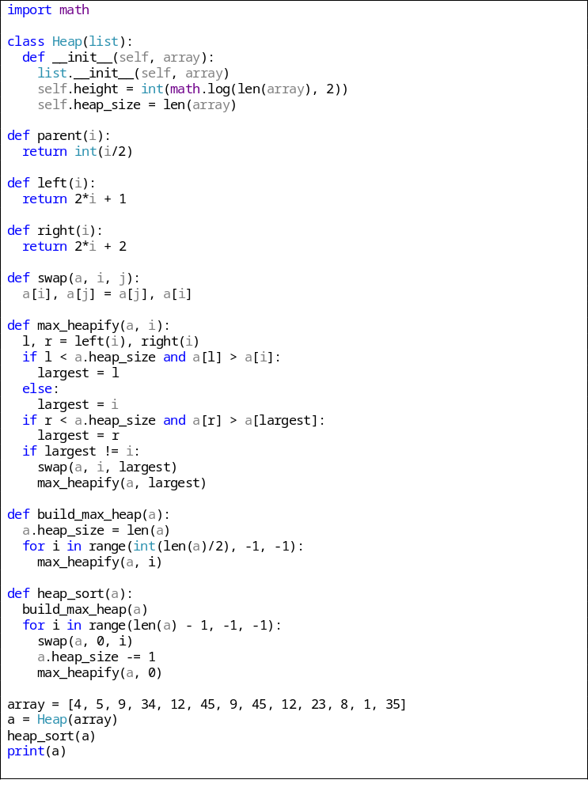

KT5.2. Simplicity is achieved in two general ways: minimizing the amount of essential complexity that anyone's brain has to deal with at any one time, and keeping accidental complexity from proliferating needlessly.
Tính đơn giản được thực hiện bằng hai cách chung: giảm thiểu sự phức tạp cơ bản mà não bất kì ai cũng có thể đối phó trong một thời điểm, và giữ sự phức tạp ngẫu nhiên khỏi phát sinh không cần thiết.

- Giảm thiểu sự phức tạp
Mục tiêu chính của thiết kế là giảm sự phức tạp. Tránh thiết kế thông minh vì chúng thường khó hiểu. Thay vào đó nên thiết kế đơn giản và dễ hiểu.
- Dễ bảo trì
- Giảm thiểu kết nối không cần thiết
Giữ kết nối giữa các bộ phận là tối thiểu, dẫn đến giảm thiểu công việc trong tích hợp, kiểm tra và bảo trì.
- Khả năng tái sử dụng
Thiết kế hệ thống để ta có thể sử dụng lại những phần của chúng trên những hệ thống khác.
- Tín hiệu vào cao
Hệ thống được thiết kế để sử dụng tốt các class có ích ở những cấp thấp trong hệ thống
- Tín hiệu ra từ thấp tới trung bình
Một class đã cho có thể sử dụng một số low-to-medium của những class khác.
- Tính linh động
Thiết kế một hệ thống mà có thể dễ dàng di chuyển chúng tới các môi trường khác.
- Leanness
Thiết kế hệ thống không có phần bổ sung.
- Sự phân lớp
Thiết kế hệ thống mà xem chúng ở một cấp mà không cần đưa vào các cấp khác.
Ví dụ: trong heapsort.py đã nêu ở trên. Chương trình tổ chức thành nhiều hàm, giúp giảm thiểu sự phức tạp và dễ đọc hơn, đồng thời hoàn toàn có khả năng tái sử dụng trên các hệ thống khác.

KT5.3. Design is heuristic. Dogmatic adherence to any single methodology hurts creativity and hurts your programs.
Thiết kế là khám phá. Tuân thủ máy móc với bất cứ phương pháp nào sẽ tổn hại đến sự sáng tạo và gây hại đến chương trình.
- Tìm đối tượng thế giới thực :
    - Nhận định đối tượng và thuộc tính của chúng.
    - Xác định điều phải làm với các đối tượng.
    - Xác định mỗi đối tượng có thể làm gì với các đối tượng khác.
    - Xác định những phần của mỗi đối tượng có thể thấy từ đối tượng khác.
    - Định nghĩa giao diện của mỗi đối tượng.
- Mẫu trừu tượng thích hợp
Các class cơ sở là trừu tượng cho phép bạn tập trung vào các thuộc tính chung và bỏ qua các chi tiết của từng class cụ thể khi đang làm việc trên class cơ sở
- Đóng gói sự triển khai chi tiết
Có thể nhìn vào tổng thể, trừu tượng nhưng không thể xác định từng chi tiết
- Kế thừa khi nó đơn giản hóa thiết kế
Xác định điểm tương đồng và khác biệt giữa các đối tượng được gọi là "kế thừa". Kế thừa là một trong những công cụ lập trình hướng đối tượng mạnh nhất.
- Thông tin ẩn
- Xác định khu vực có khả năng thay đổi
- Giữ khớp nối lỏng lẻo
- Tìm kiếm mẫu thiết kế chung

KT5.4. Good design is iterative; the more design possibilities you try, the better your final design will be.
Thiết kế tốt cần một quá trình lặp đi lặp lại; thiết kế nhiều nhất có thể, kết quả cuối sẽ tốt hơn.
Thiết kế là một chu trình lặp đi lặp lại. Từ đó thu được kinh nghiệm, kiến thức khi viết chương trình lặp nhiều lần.

KT5.5. Information hiding is a particularly valuable concept. Asking, “What should I hide?” settles many difficult design issues.
Thông tin ẩn là một biến giá trị đặc biệt. Hỏi, “Tôi nên ẩn cái gì?” giải quyết nhiều vấn đề thiết kế khó.
- Thông tin ẩn là một phần nền tảng của cả thiết kế cấu trúc và thiết kế hướng đối tượng.
- Trong thiết kế cấu trúc, khái niệm về "hộp đen" xuất phát từ thông tin ẩn.
- Trong thiết kế hướng đối tượng, nó đưa đến khái niệm về đóng gói và mô đun, và nó gắn liền với khái niệm trừu tượng.
Thông tin ẩn được công bố đầu tiên bởi David Parnas năm 1972
Ví dụ : Trong heapsort.py. Ẩn cách thức triển khai max_heapify
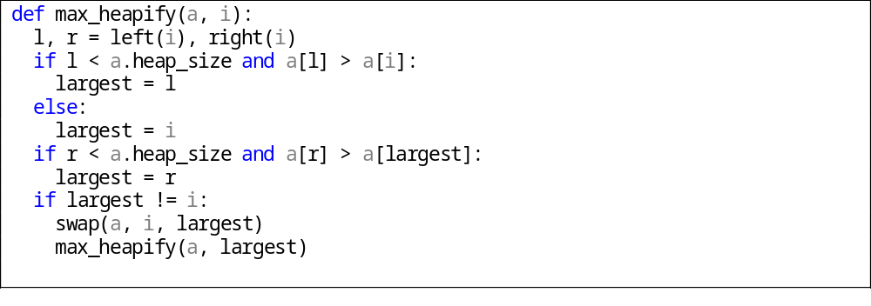

KT5.6. Lots of useful, interesting information on design is available outside this book.The perspectives presented here are just the tip of the iceberg.
Rất nhiều thông tin hữu ích, thú vị về thiết kế có bên ngoài quyển sách này. Trình bày ở trên chỉ là đỉnh của tảng băng trôi.
Trong thông tin ẩn, mỗi class được đặc trưng bởi các quyết định thiết kế hoặc xây dựng mà nó ẩn từ tất cả các class khác. Những bí mật có thể là một khu vực có khả năng để thay đổi, định dạng của một tập tin, cách một kiểu dữ liệu được thực hiện, hoặc một khu vực cần phải được ngăn cách với phần còn lại của chương trình để lỗi trong khu vực đó gây ra ít thiệt hại càng tốt. Một class có thể sử dụng 25 routines và phơi bày chỉ có 5 trong số đó, bằng cách sử dụng 20 khác trong nội bộ. Một class giống như tảng băng trôi, chỉ có một phần tám nổi trên mặt nước, bảy phần tám chìm.

III.2. Sử dụng Chương 7 – Kỹ thuật xây dựng hàm/thủ tục High-Quality Routines

KT7.1. The most important reason for creating a routine is to improve the intellectual manageability of a program, and you can create a routine for many other good reasons. Saving space is a minor reason; improved readability, reliability, and modifiability are better reasons.
Lý do quan trọng nhất để tạo một hàm là để tang khả năng quản lý của chương trình, và có thể tạo một hàm cho nhiều lý do tốt khác. Tiết kiệm bộ nhớ là một lý do nhỏ, tăng tính dễ đọc, độ tin cậy, và khả năng chỉnh sửa là các lý do quan trọng hơn.
- Giảm độ phức tạp
Lý do quan trọng nhất để tạo ra một hàm là để giảm độ phức tạp của một chương trình. Một khi hàm được tạo ra, chúng ta chỉ cần quan tâm đến việc hàm làm gì chứ không cần quan tâm đến chi tiết bên trong hàm.
- Làm cho các khối code dễ đọc hơn
Chương trình chính ngắn hơn cùng với các tên hàm gợi nhớ nội dung giúp dễ đọc hơn.
- Tránh các code lặp lại
Thay vì 1 khối code phải viết đi viết lại ở nhiều chỗ, sử dụng hàm giúp người lập trình chỉ cần viết 1 lần, kéo theo đó là việc sửa lỗi cũng dễ hơn, chỉ cần sửa ở 1 chỗ
- Dấu đi trình tự.
- Đơn giản hóa các điều kiện đúng sai phức tạp
- Tăng tính linh động
- Nâng cao hiệu suất

Ví dụ trong 7-1.py:

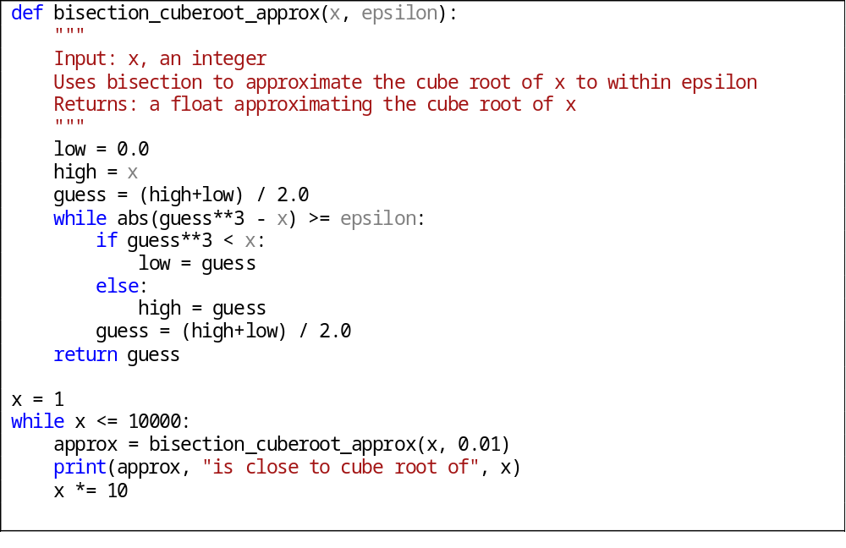

KT7.2. Sometimes the operation that most benefits from being put into a routine of its own is a simple one.
Đôi khi thao tác mà hầu hết lợi ích từ việc đưa vào một thủ tục của chính nó là là một cái đơn giản.
Xây dựng một hàm đơn giản chỉ gồm vài dòng lệnh có vẻ không cần thiết, tuy nhiên kinhi nghiệm cho thầy nó đem lại nhiều lợi ích, quan trọng nhất là tính dễ đọc.
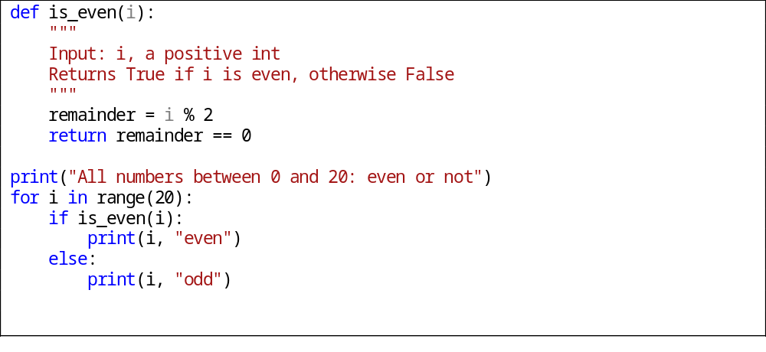
Việc kiểm tra một số là chẵn hay lẻ không phải là công việc phức tạp, thay vì sử dụng hàm, ta có thể viết như sau:

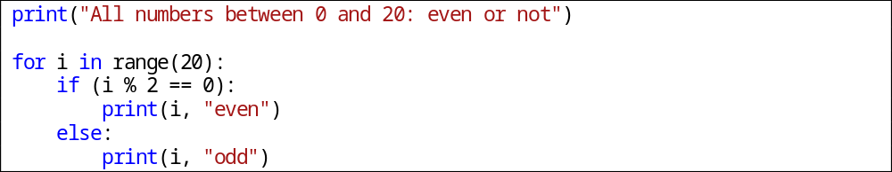

Nhưng dòng lệnh này có thể xuất hiện trong cả tá nơi để làm đúng một việc. Vì vậy nó có thể sáng sủa hơn, dễ đọc hơn

KT7.3. ‘You can classify routines into various kinds of cohesion, but you can make most routines functionally cohesive, which is best.
Bạn có thể phân loại các hàm theo sự gắn kết của nó, nhưng bạn cũng có thể làm cho hầu hết các hàm có sự gắn kết, đó là điều tốt nhất.
Đối với hàm, sự gắn kết đề cập đến việc các câu lệnh trong một hàm có liên quan như thế nào. Mục đích là để mỗi hàm chỉ làm một nhiệm vụ duy nhất.
- Functional cohesion
Là khái niệm mạnh nhất trong các loại gắn kết. Xẩy ra khi hàm chạy đúng một operation. Ví dụ cho những hàm có tính gắn kết cao: LayTenNguoiDung(), XoaFlie(),….
- Sequential cohension( tính nối tiếp)
Tồn tại trong một hàm có các operation chạy trong một thứ tự cụ thể, và chia sẻ dữ liệu từng bước, mà không tạo thành một chức năng hoàn chỉnh khi nó làm việc cùng nhau.
- Tính găn kết truyên thông
- Tính gắn kết logic

KT7.4. The name of a routine is an indication of its quality. If the name is bad and it's accurate, the routine might be poorly designed. If the name is bad and it's inaccurate, it's not telling you what the program does. Either way, a bad name means that the program needs to be changed.
Tên của một hàm là dấu hiệu cho chất lượng của nó
- Tên miêu tả mọi chức năng của hàm
Trong tên của hàm, nên miêu tả mọi đầu ra, và các các khía cạnh mà nó tác động.
- Độ dài hợp lý.
Tên hàm nên dài hơn tên biến, từ 20-35 ký tự là độ dài khá hợp lý. Tên hàm trung bình từ 15-20 ký tự.
- Khi đặt tên các thủ tục thì sử dụng các động từ theo kém danh từ như PrintDocument, CheckOrderInfo. Trong ngôn ngữ lập trình hướng đối tượng thì không cần, ví dụ: Document.Print() hay OrderInfo.Check()
- Sử dụng các từ khóa đối lập một cách chính xác: begin/end, add/remove, get/set,..
Ví dụ: 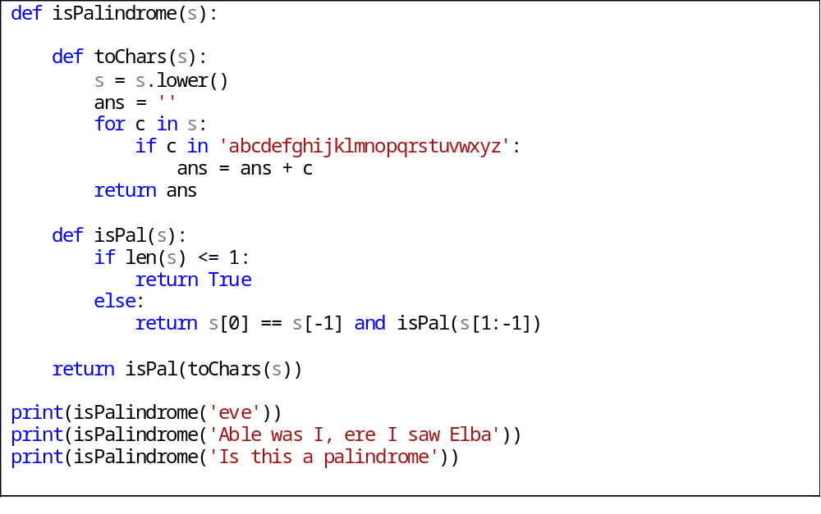

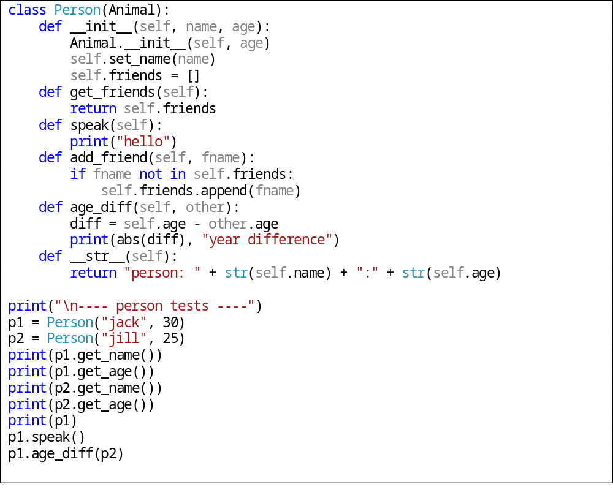Các hàm get_friends, speak, add_friend, age_diff mang tính gợi nhớ cao

KT7.5. Functions should be used only when the primary purpose of the function is to return the specific value described by the function's name.
Hàm nên được sử dụng chỉ khi mục đích cơ bản của hàm là trả về các giá trị cụ thể mà được miêu tả trong tên của hàm.
- Khi nào nên dùng thủ tục khi nào nên dùng hàm
Khi một routine trả về giá trị của tham số thì chúng ta nên dùng hàm còn nêu nó không trả về giá trị gì cả chúng ta nên dùng tham số
- Cài đặt giá trị trả về của hàm
- Kiểm tra tất cả các con đường trả về có thể:
Khi tạo một hàm, thử các khả năng để chắc chắn rằng hàm đó trả về giá trị trong mọi tình huống có thể. Tốt hơn hết là khởi tạo giá trị trả về mặc định tại phần mở đầu của hàm.
- Đừng trả về tham chiếu hoạc con trỏ đến dữ liệu cục bộ
Khi mà routine kết thúc và dữ liệu cục bộ ra khỏi bộ nhớ, tham chiếu và con trỏ đến dữ liệu cục bộ là không hợp lệ. Nếu một đối tượng cần trả thông tin về thông tin bên trong nó, nó nên lưu thông tin như là một thành phần của một class. Nó nên cung cấp hàm truy cập mà trả về giá trị của data thành viên hơn là tham chiếu và con trỏ đến dữ liệu cục bộ.

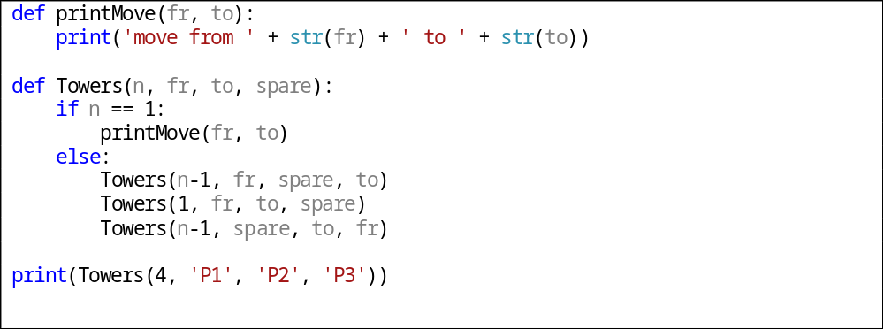
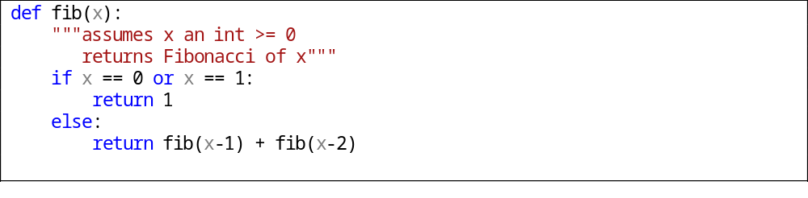

KT7.6. Careful programmers use macro routines with care and only as a last resort.
Những lập trình viên cẩn thận sẽ dùng hàm macro thật cẩn thận và chỉ dùng nó khi không còn lựa chọn khác.

III.3. Các kỹ thuật bẫy lỗi và phòng ngừa lỗi Defensive Programming

KT8.1. Production code should handle errors in a more sophisticated way than "garbage in, garbage out."
Khi viết code nên xử lý các lỗi theo một cách tinh tế hơn “garbage in, garbage out”.
Một chương trình tốt không bao giờ có output là rác, bất kể input là gì. Có 3 cách để xử lý input là rác.
Kiểm tra các giá trị của tất cả dữ liệu ở các nguồn bên ngoài: Đảm bảo chúng nằm trong khoảng cho phép.
Kiểm tra các giá trị của tham số: Tương tự như trên, chỉ khác ở chỗ tham số được truyền từ hàm khác, thay vì từ nguồn bên ngoài.
Quyết định làm thế nào để xử lý đầu vào không tốt.

KT8.2. Defensive-programming techniques make errors easier to find, easier to fix, and less damaging to production code.
Các kỹ thuật phòng ngừa làm cho lỗi dễ dàng phát hiện, dễ dàng sửa và giảm thiệt hại đối với toàn bộ chương trình.

KT8.3. Assertions can help detect errors early, especially in large systems, high-reliability systems, and fast-changing code bases.
Assertions có thể giúp phát hiện các lỗi sớm, đặc biệt là trong các hệ thống lớn, hệ thống có độ tin cậy cao, và cơ sở code thay đổi liên tục. Assertions thường được dùng để kiểm tra tính đúng sai của câu lệnh. Assertions thường được dùng trong các chương trình lớn, phức tạp và có độ tin cậy cao. Một assertion gồm 2 mệnh đề: 1 hàm boolean kiểm tra đúng sai và 1 thông báo nếu xảy ra lỗi.
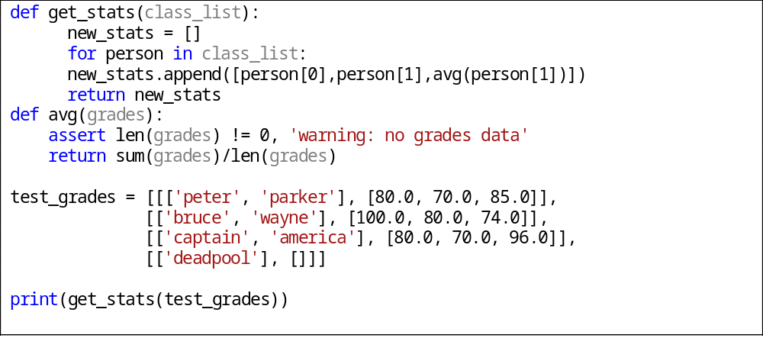

KT8.4. The decision about how to handle bad inputs is a key error-handling decision and a key high-level design decision.
Quyết định làm thế nào để xử lý bad inputs là chìa khóa để xử lý lỗi.
Assertion được dùng để xử lý lỗi không được phép xuất hiện, vậy làm thế nào để xử lý những lỗi mà bạn mong muốn nó xảy ra. Tùy vào từng trường hợp cụ thể mà bạn có thể có những cách sau đây:
Trả lại 1 giá trị trung lập
Ví dụ: return 0;
Thay thế phần dữ liệu tiếp theo đó.
Trả lại câu trả lời như lần trước đó.
Thay thế giá trị hợp lệ gần nhất.
Hiện 1 thông báo lỗi ở bất kỳ đâu phát hiện ra lỗi.
Một vài hệ thống tự động shutdown bất kỳ lúc nào nó phát hiện ra lỗi.

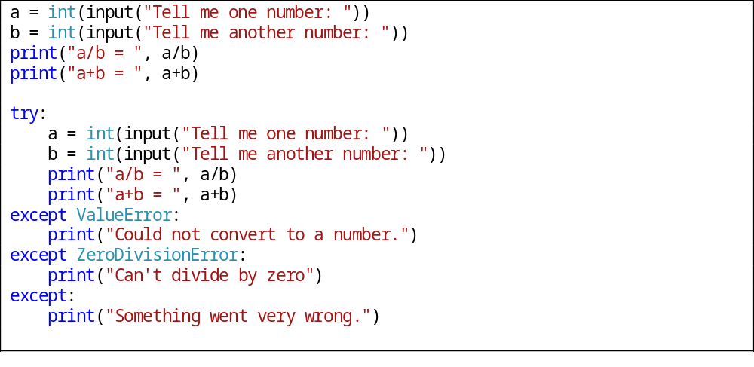

KT8.5. Exceptions provide a means of handling errors that operates in a different dimension from the normal flow of the code. They are a valuable addition to the programmer's intellectual toolbox when used with care, and they should be weighed against other error-processing techniques.
Các trường hợp ngoại lệ cung cấp 1 cách thức xử lý lỗi được tổ chức theo từng phần của dòng code. Đây là 1 công cụ tiện dụng đối với người lập trình, nên được cân nhắc sử dụng cẩn thận.
- Sử dụng ngoại lệ để thông báo lỗi cho các phần khác của chương trình.
- Báo trường hợp ngoại lệ chỉ đối với những điều kiện thực sự đặc biệt
- Nếu một trường hợp lỗi có thể xử lý địa phương thì không nên dùng exception
- Bao gồm trong thông báo ngoại lệ tất cả các thông tin dẫn đến ngoại lệ
- Cân nhắc những phương pháp khác thay thế
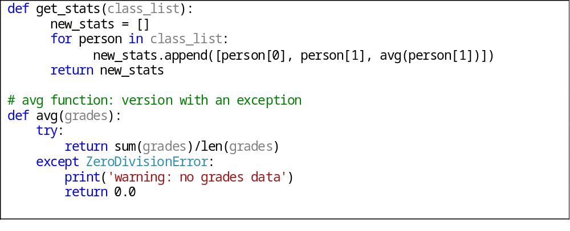

KT8.6. Constraints that apply to the production system do not necessarily apply to the development version. You can use that to your advantage, adding code to the development version that helps to flush out errors quickly.
Những ràng buộc áp dụng đối với sản phầm không cần thiết phải áp dụng cho phiên bản phát triển. Do đó, người lập trình có thể thêm các dòng lệnh để phát hiện các lỗi nhanh chóng.
Phiên bản sản phẩm phải chạy nhanh, tài nguyên hạn chế, độ an toàn cao. Trong khi bản phát triển có thể chạy chậm, sử dụng lượng tài nguyên lớn, có thể chạy các chức năng mà chưa cần quan tâm đến vấn đề an toàn
Người lập trình có thể thêm các dòng lệnh để phát hiện các lỗi nhanh chóng.

- Sử dụng các dòng lệnh cho các lỗi quan trọng.
- Có thể bỏ qua việc kiểm tra các lỗi không đáng kể. Bỏ ở đây không có nghĩa loại bỏ hoàn toàn dòng lệnh mà sử dụng các kĩ thuật đặc biệt để không biên dịch phần chương trình đó.
- Bỏ các dòng lệnh dẫn đến sự sụp đổ.
Trong quá trình phát triển, khi chương trình phát hiện ra lỗi, người lập trình sẽ muốn lỗi càng thấy rõ càng tốt để có thể khắc phục lỗi. Thông thường chương trình in một thông điệp và sụp đổ khi phát hiện ra lỗi. Còn đối với bản sản phẩm, để tránh việc mất dữ liệu của người dùng, ta cần loại bỏ những đoạn chương trình này.

